**AP 212 ECG Assignment: KEY**

**Identify these ECG parts and their clinical significance on the sample ECG below:**

***A) Wave Amplitude***: mVolts or mm paper deflection (boxes) from ECG baseline to farthest part of the wave from the baseline as + or – mm or mV. Remember that the size of the ventricles in part determines R-amplitude (a large ventricle creates large R-amplitude). How could you use this to determine if you have an enlarged ventricle or atria?

***B) PR- Interval***: time between start of atrial depolarization and start of ventricular depolarization. This asks if AV node conducts depolarization through properly. How could you use this to determine if you have a Heart block?

***C) QT-Interval***: time between start of ventricular depolarization and end of ventricular repolarization. Asks how much time is spent with the ventricle depolarized. A long QT-interval means there is less time to deliver oxygen to the heart, why is this helpful for determining if your heart receives enough oxygen?

***D) ST Segment***: time between end of ventricular depolarization and start of T-wave. If a person had a short ST segment, the heart would have little time to generate force. Why might this explain why a person with a normal heart rate, and a short ST-segment might be chronically tired and have a smaller than normal cardiac output?

***E) RR-Interval***: time between the same point on two adjacent QRS complexes….typically the R-wave is used. This is used to determine heart rate. This is how we look for sinus bradycardia (-60 bpm) or sinus tachycardia (+100 bpm). Therefore: ↑ rate= possible ↑ oxygen demands AND ↓ rate= possible ↓ delivery to heart and body.

***F) P-P Interval***: Time from start of atrial depolarization to start of next atrial depolarization. This is used to determine if atrial and ventricular rates are the same of different. If the two rates are not identical, you have a AV heart block, why is this important?.

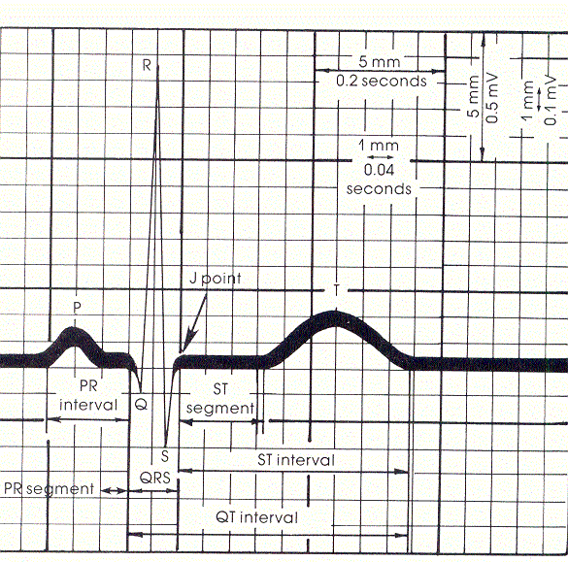

***Very Important Rules to Live By!***

***VIP #1:*** A depolarization need not create a contraction! If there is inadequate ATP or calcium the muscle may not be strong enough to eject blood (ECG with observed contraction). ALWAYS CHECK FOR A PULSE TO CONFIRM THE ECG!

***VIP#2:*** A contraction need not create ventricular ejection! While the pressure in the ventricle may increase following depolarization and contraction, it MAY NOT be enough to push blood out, especially if ventricular wall is over stretched. ALWAYS CHECK FOR A PULSE TO confirm ECG!

***VIP#3:*** The Atrial rate is a poor choice for measuring “heart” rate because it MAY NOT always translate to a ventricular rate. This happens in 2nd and 3rd degree heart block.

NEVER MEASURE HEART RATE WITH PP-INTERVAL!

***VIP#4:*** Intervals and Segments are variable from beat to beat, never measure just one and assume all are the same. Try to measure an average if at all possible.

Average (mean)= sum of observed values/number of observed values

Example of RR-intervals measured three different times:

(0.9 sec/beat+0.7sec/beat+0.8 sec/beat)(1/3)= (2.4 sec/beat)(1/3) = 0.8 sec/beat

Average heart rate therefore is (0.8 beats/second)(60seconds/minute)= 48 beats/minute

***Determining Elapsed Time (Seconds or Minutes) and Voltage (mV) from ECG scale: (For lab and lecture exam)***

If the paper moves at 20 mm/second, and you looked at the ECG during a 100 mm length of paper, you would be looking at (100mm)(1second/20mm)=5 seconds of ECG/heart function events recorded on the paper. If the paper moved at 10 mm/second and you looked at 200 mm of paper ECG recordings, you would be looking at the cardiac events that occurred during a 20 second period of time (200 mm X 1 second/10 mm= 20 seconds).

If the scale for the Y-axis was 10mm per mvolt (10mm/1mV) and an R-wave was 5 mm tall, the R-wave would have been (5mm)(1mV/10mm)= 0.5 mVolts in amplitude when the ECG was recorded.

***Look at the Sample ECG below and Answer the Following Questions: (1-8= 1pt/each; Que9=2pts)***

***Assume:*** X-axis is time (20 small boxes/second) Y-axis is voltage (10 small boxes/1 mVolt)

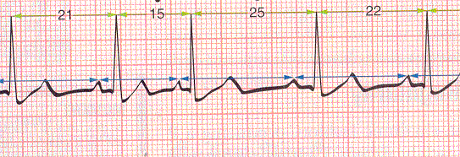

1) How much time did it take to complete each cycle of contraction? (RR- Interval)

***As mentioned above assume the boxes are 1mm each, they are not after schles chance with photocopy and printing of this paper on your printers. :o)***

RR #1:__21mm__RR#2:___15mm_____ RR#3:____25mm_____ 🡪Average__(20.3 mm)(1sec/20mm)= 1.015 seconds

***Note: it depends a bit upon which RR intervals you choose to look at….you get a slightly different number if you choose to look at the last three cycles. I asked you to measure three individual RR-intervals so you would see why we need to average across at least 3 RRs, and to remember that an average of 5 is even better.***

Is this a normal heart rate?__(1 beat/second) (60 sec/min)= 60 beats/min___ Is this sinus bradycardia, normal sinus rhythm, or sinus tachycardia?________Normal Sinus Rhythm

2) How much time was required for the depolarization to pass through the AV Node (and atria)? (PR-Interval)

PR-I #1:___4mm______PR-I#2:____4mm_____PR-I#3:__5mm__ 🡪Average=__(4.3mm)(1sec/20mm)= 0.21 sec_

Would this time increase or decrease if the person developed a 1st degree heart block later in the day?

***First degree blocks imply slow passage through the AV node……PR-Interval would increase***

3) How much time did the ventricle spend either depolarized or repolarizing? (QT-Interval)

QT-I#1:______11mm__QT-I#2:__8mm___QT-I#3:_11mm____ 🡪Average=___(10mm)(1sec/20mm)=0.5 sec__

If the QT-interval became longer, would the hearts oxygen demands go up or down?

***As the heart spends more time in systole (QT-interval) it spends more time at work generating force and using up ATP and the oxygen used to make ATP in the mitochondria.***

4) How much time did the heart spend generating force? (ST-Segment)……***This is a tough one to measure on these ECGs because the S-wave pretty much smoothly transitions into the T-wave….some tiems you will have a flat spot that can be more easily measured.***

What are actin and myosin in the cardiomyocytes doing once calcium has allowed troponin to be removed from myosin? (Assume adequate ATP supplies)

***Once troponin is removed from actin by the presence of calcium, you hopefully observe Contracting, Generating Force and hopefully creation of a stoke volume of blood that leaves the ventricle🡪Cardiac Output***

5) How much time did the heart spend in diastole? (time from end of T-wave to start of next P-wave)

TP#1:__9mm___TP#2:___5mm______TP#3:___9mm____ 🡪Average=__(7.67mm)(1sec/20mm)= 0.38 sec_____

If the heart rate increased and the QT-interval was unchanged would the T-P time increase or decrease? WHY?

***Tough reality of the heart is that as the rate goes up, the heart spends less and less time in diastole, so the heart literally does more work, uses more oxygen at the same time that it supplies itself with LESS oxygen***

*This is tricky, but helps explain why eventually an increasing heart rate means blood and oxygen supply to the heart actually DECREASE at the same time the oxygen demand INCREASES.--> This is a frequent cause of exercise induced angina (localized cardiac hypoxia/ischemia or heart attack).*

*You need not use the above ECG to answer questions 7-10*

6) Why does the heart rate have an upper maximum rate in an adult of about 200 beats/minute? What happens to the time available for diastolic filling and ejection as the rate continues to increase? If cardiac output drops does oxygen supply to the heart drop? Why are heart attacks likely if your rate goes beyond 200 bpm?

***Somewhere around 180 to 200 beats per minute is the upper limit of what the heart can do for several reasons any or all of which can lead to the demise of your heart. At this rate, the heart is supplying itself with less oxygen and using more oxygen, it is also having a hard time removing all the accumulated carbon dioxide. This generates local hypoxia and hypercapnia, both are factors that shift the Frank-Starling Curve for the heart down and to the right (towards failing side). The other problem is that with a very short diastole, the AV valves that let blood enter the ventricle are open for only a very short time, therefore the ventricle cant get a large enough preload to generate a forceful contraction. All these things mean that you are more likely to suffer a heart attack. Other items also occur and may be in your answer, these are just a few***.

7) Relative to a normal person (70 beats/minute; Stroke Volume=70 ml), consider a person who has bradycardia (HR=45) at rest and seems to be perfectly healthy. What might you expect the size of the left ventricle to be relative to a normal person? (Larger or Smaller) What would you expect the stroke volume to be like? (Larger or Smaller) What would you expect the R-wave amplitude to be Larger or Smaller than normal if you looked at Lead II?

***Persons who exercise tend to have hearts that can handle large preloads (exercise🡪 increased venous return🡪increased preload🡪 increased cardiac output). The trick is that like all muscles, the heart responds to the increased workload and literally gets larger allowing it to do baseline work with a massive stroke volume and slow resting heart rate (Example: if resting preload increased from 75 ml[ (75ml/b)(70b/min)=5.2 L/min] to 100 ml [(5.2L/min)/(120 ml/b)= 43 beats/minute], the heart rate needed to maintain 5 liters/minute can dropped 70 to just 43 meats per minute. Here is the TRICK!***

***If you know the heart has a maximum rate of 180 beats/minute……who can increase their cardiac output the most? The athlete or the “Couch Potato”? ASSUME THE STROKE VOLUME STAYS UNCHANGED***

***“Couch”: 70 beats/minute= 5.2 L/min at 70 ml/beat🡪 at 180 beats/min this person can have a maximum cardiac output of 12,600 ml/minute or 12.6 L/min. Output could basically double….not bad right?***

***“Athlete”: 43beats/minute= 5.2 L/minute at 120 ml SV🡪 at 180 beats/min this persons CO is now BETTER!***

***Cardiac Output= (120ml/beat)(180 beats/min)= 21,600 ml/minute or 21.6 Liters/minute!***

***CARDIAC OUTPUT COULD INCREASE OVER FOUR TIMES WHAT IT STARTED AT, THIS MEANS THEIR HEART HAD A GREATER RANGE OF HEART RATES WITHIN WHICH TO OPPERATE AND MAINTAIN HOMEOSTATIS.***

***THE metabolic COST OF COURSE IS THAT LARGE MUSCLES ARE EXPENSIVE TO MAINTAIN, THIS IS WHY MUSLCES THAT ARE NOT EXERCISES REGULARLY RAPIDLY ATROPHY OR GET “FLABBY”***

8-10) Watch for these cardiac conditions in the laboratory this week, they are much more common than you might think and need not always indicate a serious medical condition. Although sometimes they are important indicators of disease. ***It is always advised that you always see your physician for full medical recommendations and not trust the observations made in AP 212 lab using equipment that is not clinical grade. (2points)***

***A) Sinus Bradycardia:*** slower than 60 bpm-very common

***B) Sinus Tachycardia***: faster than 100 bpm-somewhat common

***C) 1st Degree Heart Block:*** AV Node delays passage of depolarization to ventricles a bit too much (PR Interval greater than 0.2 seconds)

***D) 2nd Degree Heart Block:*** Some atrial depolarizations fail to pass through the AV node (P-wave without a QRS)

***E) 3rd Degree Heart Block:*** Atrial rate different from ventricular rate (PP-Intervals different from RR Intervals)

***F) PVC or PreVentricular Contraction:*** Part of ventricle becomes an ectopic foci (no preceding P-wave) and creates a depolarization with bizarre Q, R or S-waves because the depolarizations are not moving in the normal directions.

PCVs often occur following hypoxia/ischemia/infarct and often leads to a fatal pattern of cardiac fibrillation.

***G) Ventricular Fibrillation:*** This irregular saw-toothed ECG pattern indicated there is no organized electrical conduction pathway in use. All parts are depolarizing in random fashion and no ventricular ejection is occurring. If this occurs, you will become unconscious in a matter of seconds (hypoxia in brain) and if the condition is not rapidly fixed, brain damage will begin in a matter of a few minutes. You have to hope the heart reverts on its own to a normal rhythm or that someone uses a “defribrillator” to return your heart of normal conduction with an electric shock. CPR is often given while you wait for a defibrillation unit to arrive! (Call 911 if this is ever observed!)

**NOTE: In lab often times an APPARENT fibrillation occurs because the electrodes are loose or because you are contracting skeletal muscles that *can also create waves of depolarization*.**

Match these ECG patterns to A-F above (all will be used at least once, and some could be used more than once).

Write the name with proper letter on the assignment you hand in.

***On these recordings the P-wave from atrial depolarization is often just a slight bump before the large QRS.***

***Paper Speed: ASSUME that the paper speed for the ECGs below is 0.2 second per one large box (5mm).***

***Therefore 1 second=5 big boxes***

***Second degree heart block because the second P-wave did not create a ventricular depolarization.***

P-wave P P P P P-wave



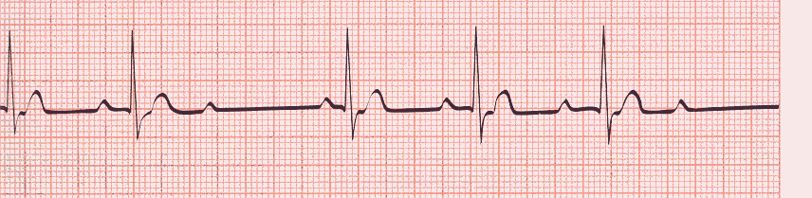



P

**Sinus Tachycardia because each ventricular depolarization has a P-wave in front and the heart rate is very fast.**



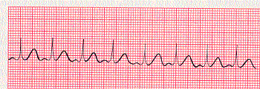



***Sinus Bradycardia because each ventricular depolarization has a P-wave in front and the heart rate is very slow.***

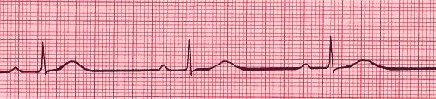



*Pre-Ventricular Contraction (PVC)….the funky looking middle depolarization has no P-wave and is shaped totally different from the other regular looking depolarization cycles.*

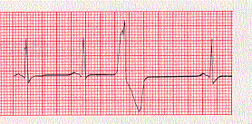



***First degree heart block because the second P-R interval is very very long…..the depolarization did finally reach the ventricle but only after a very long delay in the AV*** ***node. (you could also call this Sinus Bradycardia due to slow rate of ventricular depolarization).*** *A person “could” make a case for third degree heart block (maybe****). ECGs are like this, not always absolutely definitive, that’s a good lesson to take home for clinicals.***



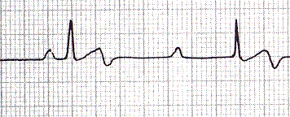

*Third Degree Heart Block because the P-wave rate and the ventricular depolarization rate are totally different and if you look at the record, a P-wave is not required for the ventricle to depolarize. The ventricles is now using another node as the pacemaker (perhaps AV node itself or the apex)*

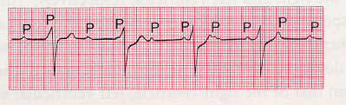



***Saw-Toothed Pattern means Ventricular Fibrillation! YIKES!***

***All cardiac output has effectively stopped and you will go unconscious in a matter of seconds….hope that someone is kind enough to defibrillate your heart***.

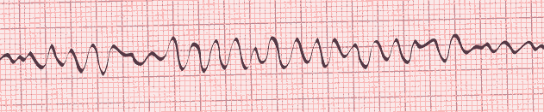



**VERY IMPROTANT RULE TO REMEMBER! JUST BECAUSE YOU SEE A VENTRICULAR DEPOLARIZATION ON THE ECG, THIS DOES NOT MEAN THERE *HAS* TO BE A STROKE VOLUME OF BLOOD LEAVIGN HEART AND A PULSE IN THE ARTERIES…. ☺ Always confirm ECG observations by looking for an actual pulse.**

**Match the ECG record numbers (1-7) to the terms listed above:**

**See notes above…….**

***MEA Calculations.***

1) Measure the net amplitude of the QRS complex for leads I, II and III. Net QRS Amplitude: Look at the two largest waves, if the R-amplitude is +9mm and the S-amplitude is -3mm, the net amplitude would be (+9mm) – 3mm = +6mm

2) From the center of each lead line on Einthoven’s Triangle (I, II and III), move that number of mm in the positive or negative direction from the center and place a “mark” at this spot on each lead line.

3) Draw perpendicular lines to each “mark” and circle the place where the three perpendicular lines intersect (or best estimate of the intersection point).

4) Draw a line from the center of the triangle to the center of the intersection.

5) Look and see how many degrees this line is at. This is the average vector taken during the depolarization of the heart that you are evaluating.

6) A Normal heart depolarizes down and towards the left (0o to +90o ). Right Axis Deviation is anything from (+90o to +180o ). Left Axis Deviation is anything from (0o to -90o ).

***1 Point Each: For each MEA indicate the exact degrees AND DESCRIBE TWO THINGS that could cause this shift to have occurred.***

***MEA #1_____________________________ MEA #2***

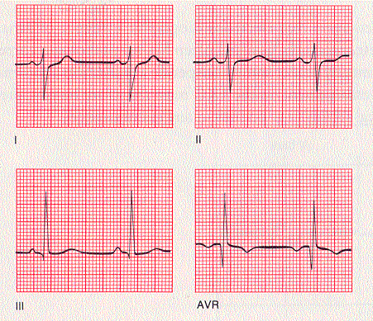 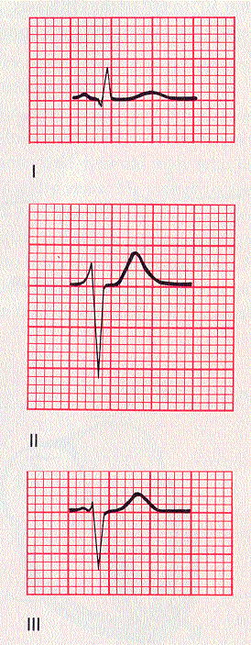



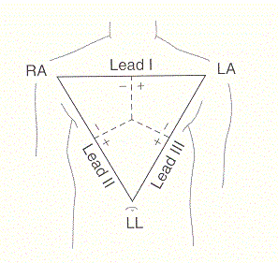 



***Remember that the typical heart I nthe typical person has an average depolarization which travels down and to the left. This is in the range of 0 to +90 degrees. Shifts up are “Left” deviations and shifts to down and across are “Right” deviations.***

***MEA#1: Solve for triangle and degrees.***

***The MEA is ____degrees and is a _____shift. What are two things that could cause this shift?***

***Lead I: +5mm-10mm= -5mm net; Lead II: +5mm-7mm=-2mm net; Lead III:+16mm-2mm=+14mm net***

***Move the net #mm in the positive or negative direction for each lead, draw intersecting lines and solve MEA.***

***This would be a Right Axis Shift (About +160 degrees)….perhaps the person had an infarct in the left ventricle and lost myocardial tissue there (no longer contributes a depolarization) or perhaps the person had a massive right ventricle due to damage to a stenotic RT semilunar vavle that would not open properly?***

***MEA#2: MEA is ____degrees and is a _____shift. What are two things that could cause this shift?***

***Lead I: +4mm-0.5mm= +3.5mm net; Lead II: +3mm-11mm= -8mm net; Lead III: +1mm-6mm= -5mm net***

***Move the net #mm in the positive or negative direction for each lead, draw intersecting lines and solve MEA.***

***This would be a left axis shift (about -80 degrees) and could be caused by many things including an enlarged left ventricle of perhaps due to a stenotic aortic valve or shift could be created if a normal ventricle is physically pushed up by a tumor that sits underneath it.***

***When looking at ECGs remember that it is not an absolute measure of heart function, especially with respect to MEAs. Many options for causing Right or Left shifts from normal. However if you DO see an unusual ECG it does give the clinician a reason to forward the patient on for more expensive testing.***

***Calculate the two MEA Values on the Einthoven’s Triangles shown above with a ruler that has mm.***