**AP 212 ECG Assignment: 12 points**

**Hand in a *separate sheet* with name, lecture time and answers.**

***Due by 5pm Wednesday Feb 20th, hand it in on Friday in lecture if you can (completing this will also help for lab exam). -2 points if handed in late***

**Identify these ECG parts and their clinical significance on the sample ECG below:**

***A) Wave Amplitude***: mVolts or mm paper deflection (boxes) from ECG baseline to farthest part of the wave from the baseline as + or – mm or mV. Remember that the size of the ventricles in part determines R-amplitude (a large ventricle creates large R-amplitude). How could you use this to determine if you have an enlarged ventricle or atria?

***B) PR- Interval***: time between start of atrial depolarization and start of ventricular depolarization. This asks if AV node conducts depolarization through properly. How could you use this to determine if you have a Heart block?

***C) QT-Interval***: time between start of ventricular depolarization and end of ventricular repolarization. Asks how much time is spent with the ventricle depolarized. A long QT-interval means there is less time to deliver oxygen to the heart, why is this helpful for determining if your heart receives enough oxygen?

***D) ST Segment***: time between end of ventricular depolarization and start of T-wave. If a person had a short ST segment, the heart would have little time to generate force. Why might this explain why a person with a normal heart rate, and a short ST-segment might be chronically tired and have a smaller than normal cardiac output?

***E) RR-Interval***: time between the same point on two adjacent QRS complexes….typically the R-wave is used. This is used to determine heart rate. This is how we look for sinus bradycardia (-60 bpm) or sinus tachycardia (+100 bpm). Therefore: ↑ rate= possible ↑ oxygen demands AND ↓ rate= possible ↓ delivery to heart and body.

***F) P-P Interval***: Time from start of atrial depolarization to start of next atrial depolarization. This is used to determine if atrial and ventricular rates are the same of different. If the two rates are not identical, you have a AV heart block, why is this important?.

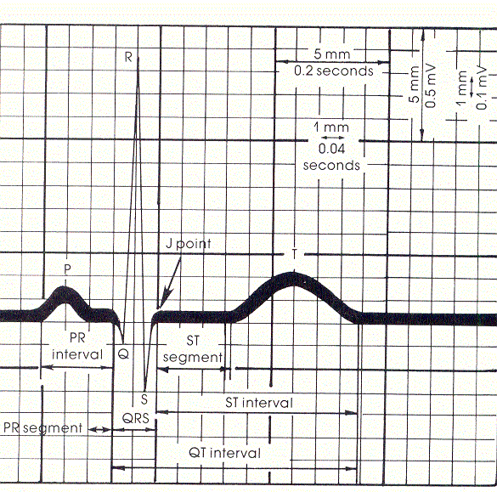

***Very Important Rules to Live By!***

***VIP #1:*** A depolarization need not create a contraction! If there is inadequate ATP or calcium the muscle may not be strong enough to eject blood (ECG with observed contraction). ALWAYS CHECK FOR A PULSE TO CONFIRM THE ECG!

***VIP#2:*** A contraction need not create ventricular ejection! While the pressure in the ventricle may increase following depolarization and contraction, it MAY NOT be enough to push blood out, especially if ventricular wall is over stretched. ALWAYS CHECK FOR A PULSE TO confirm ECG!

***VIP#3:*** The Atrial rate is a poor choice for measuring “heart” rate because it MAY NOT always translate to a ventricular rate. This happens in 2nd and 3rd degree heart block.

NEVER MEASURE HEART RATE WITH PP-INTERVAL!

***VIP#4:*** Intervals and Segments are variable from beat to beat, never measure just one and assume all are the same. Try to measure an average if at all possible.

Average (mean)= sum of observed values/number of observed values

Example of RR-intervals measured three different times:

(0.9 sec/beat+0.7sec/beat+0.8 sec/beat)(1/3)= (2.4 sec/beat)(1/3) = 0.8 sec/beat

Average heart rate therefore is (0.8 beats/second)(60seconds/minute)= 48 beats/minute

***Determining Elapsed Time (Seconds or Minutes) and Voltage (mV) from ECG scale: (For lab and lecture exam)***

If the paper moves at 20 mm/second, and you looked at the ECG during a 100 mm length of paper, you would be looking at (100mm)(1second/20mm)=5 seconds of ECG/heart function events recorded on the paper. If the paper moved at 10 mm/second and you looked at 200 mm of paper ECG recordings, you would be looking at the cardiac events that occurred during a 20 second period of time (200 mm X 1 second/10 mm= 20 seconds).

If the scale for the Y-axis was 10mm per mvolt (10mm/1mV) and an R-wave was 5 mm tall, the R-wave would have been (5mm)(1mV/10mm)= 0.5 mVolts in amplitude when the ECG was recorded.

***Look at the Sample ECG below and Answer the Following Questions: (1-7= 1pt/each; Que9=3pts)***

Assume: X-axis is time (20mm or **20 small boxes/second**) Y-axis is voltage (10 mm or **10 small boxes/1 mVolt**)

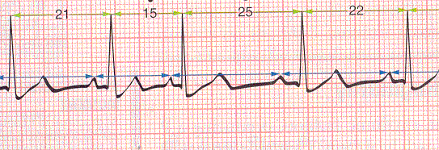

***QUE 1)*** How much time did it take to complete each cycle of contraction? (RR- Interval)

RR #1:___________RR#2:________ RR#3:_________ 🡪Average__________________

Is this a normal heart rate?________ Is this sinus bradycardia, normal sinus rhythm, or sinus tachycardia?________

***QUE 2)*** How much time was required to pass through the AV Node (and atria)? (PR-Interval)

PR-I #1:_________PR-I#2:_________PR-I#3:__________ 🡪Average=______________

Would this time increase or decrease if the person developed a 1st degree heart block later in the day?

***QUE 3)*** How much time did the ventricle spend either depolarized or repolarizing? (QT-Interval)

QT-I#1:______________QT-I#2:____________QT-I#3:________ 🡪Average=______________

If the QT-interval became longer, would the hearts oxygen demands go up or down?

***QUE 4)*** How much time did the heart spend generating force? (ST-Segment)

What are actin and myosin in the cardiomyocytes doing once calcium has allowed troponin to be removed from myosin? (Assume adequate ATP supplies)

*QUE 5)* How much time did the heart spend in diastole? (time from end of T-wave to start of next P-wave)

TP#1:____________TP#2:______________TP#3:_____________ 🡪Average=____________

If the heart rate increased and the QT-interval was unchanged would the T-P time increase or decrease? WHY?

*This is tricky, but helps explain why eventually an increasing heart rate means blood and oxygen supply to the heart actually DECREASE at the same time the oxygen demand INCREASES.--> This is a frequent cause of exercise induced angina (localized cardiac hypoxia/ischemia or heart attack).*

***You need not use the above ECG to answer questions 6-8***

***QUE 6)*** Why does the heart rate have an upper maximum rate in an adult of about 200 beats/minute? What happens to the time available for diastolic filling and ejection as the rate continues to increase? If cardiac output drops does oxygen supply to the heart drop? Why are heart attacks likely if your rate goes beyond 200 bpm?

***QUE 7)*** Relative to a normal person (70 beats/minute; Stroke Volume=70 ml), consider a person who has bradycardia (HR=45) at rest and seems to be perfectly healthy. What might you expect the size of the left ventricle to be relative to a normal person? (Larger or Smaller) What would you expect the stroke volume to be like? (Larger or Smaller) What would you expect the R-wave amplitude to be Larger or Smaller than normal if you looked at Lead II?

Watch for these cardiac conditions in the laboratory this week, they are much more common than you might think and need not always indicate a serious medical condition. Although sometimes they are important indicators of disease.

***It is always advised that you always see your physician for full medical recommendations and not trust the observations made in AP 212 lab using equipment that is not clinical grade.***

***A) Sinus Bradycardia:*** slower than 60 bpm-very common

***B) Sinus Tachycardia***: faster than 100 bpm-somewhat common

***C) 1st Degree Heart Block:*** AV Node delays passage of depolarization to ventricles a bit too much (PR Interval greater than 0.2 seconds)

***D) 2nd Degree Heart Block:*** Some atrial depolarizations fail to pass through the AV node (P-wave without a QRS)

***E) 3rd Degree Heart Block:*** Atrial rate different from ventricular rate (PP-Intervals different from RR Intervals)

***F) PVC or Preventricular Contraction:*** Part of ventricle becomes an ectopic foci (no preceding P-wave) and creates a depolarization with bizarre Q, R or S-waves because the depolarizations are not moving in the normal directions.

PCVs often occur following hypoxia/inschemia/infarct and often leads to a fatal pattern of cardiac fibrillation.

***G) Ventricular Fibrillation:*** This irregular saw-toothed ECG pattern indicated there is no organized electrical conduction pathway in use. All parts are depolarizing in random fashion and no ventricular ejection is occurring. If this occurs, you will become unconscious in a matter of seconds (hypoxia in brain) and if the condition is not rapidly fixed, brain damage will begin in a matter of a few minutes. You have to hope the heart reverts on its own to a normal rhythm or that someone uses a “defribrillator” to return your heart of normal conduction with an electric shock. CPR is often given while you wait for a defibrillation unit to arrive! (Call 911 if this is ever observed!)

**NOTE: In lab often times an APPARENT fibrillation occurs because the electrodes are loose or because you are contracting skeletal muscles that *can also create waves of depolarization*.**

***QUE 8)*** Match these ECG patterns to A-F above. Write the name with proper letter on the assignment you hand in.

***On these recordings the P-wave from atrial depolarization is often just a slight bump before the large QRS.***

***Paper Speed: ASSUME that the paper speed for the ECGs below is 0.2 second per one large box (5mm).***

***Therefore 1 second=5 large boxes***

I-----------------> 1 second

P-wave P P P P P-wave



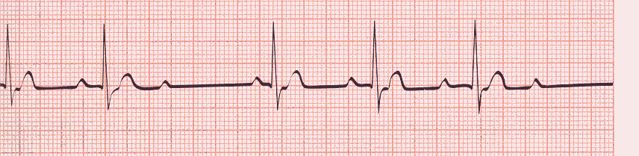



P



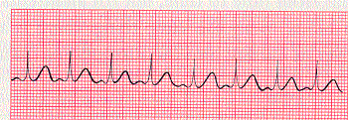



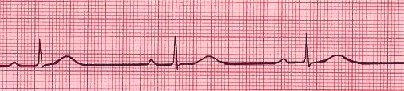



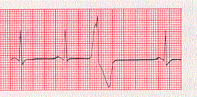



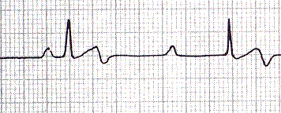

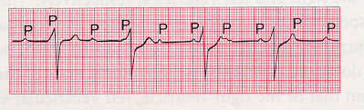



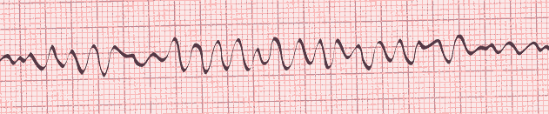



**3 Points: Match the ECG record numbers (#1-7 above) to the terms listed (A-G) above:**

**Some may be used twice and some may not be used at all.**

**QUE 8) A=_______ B=_______ C=________ D=_______ E=________F=___________G=__________**

***Calculate MEA using the examples given below:***

1) Measure the net amplitude of the QRS complex for leads I, II and III. Net QRS Amplitude: Look at the two largest waves, if the R-amplitude is +9mm and the S-amplitude is -3mm, the net amplitude would be (+9mm) – 3mm = +6mm

2) From the center of each lead line on Einthoven’s Triangle (I, II and III), move that number of mm in the positive or negative direction from the center and place a “mark” at this spot on each lead line.

3) Draw perpendicular lines to each “mark” and circle the place where the three perpendicular lines intersect (or best estimate of the intersection point).

4) Draw a line from the center of the triangle to the center of the intersection.

5) Look and see how many degrees this line is at. This is the average vector taken during the depolarization of the heart that you are evaluating.

6) A Normal heart depolarizes down and towards the left (0o to +90o ). Right Axis Deviation is anything from (+90o to +180o ). Left Axis Deviation is anything from (0o to -90o ).

***1 Point Each: For each MEA indicate the exact degrees AND DESCRIBE THE PATHOPHYSIOLOGY OF THINGS that could cause this shift to occur.***

***MEA #1_____________________________ MEA #2***

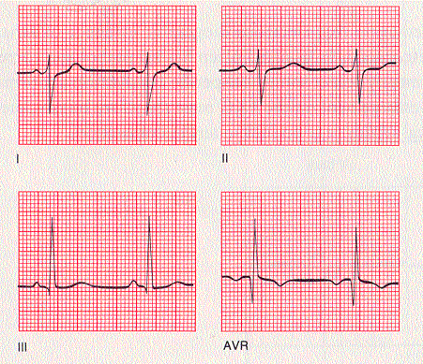 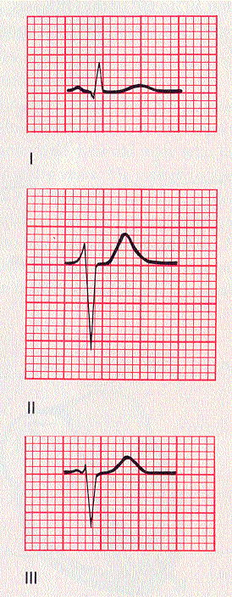

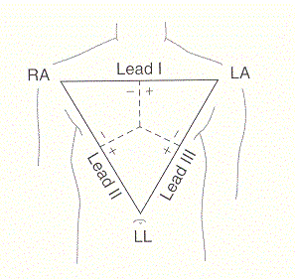 

***MEA#1: The MEA is ____degrees and is a _____shift. What are two things that could cause this shift?***

***MEA#1: The MEA is ____degrees and is a _____shift. What are two things that could cause this shift?***

***Calculate the two MEA Values on the Einthoven’s Triangles shown above with a ruler that has mm.***

***Show your measurements/calculations/triangulation on the two Torso Diagrams shown above.***