Biology 212: Anatomy and Physiology II
Lab #10: Anatomy of the Reproductive System
References: Saladin, KS: Anatomy and Physiology, The Unity of Form and Function 7th (2015) Be sure you have read and understand Chapters 27 and 28 before beginning this lab.

With COVID we are not allowed to have open lab or in-house lab activities. When the lab manual says to look at a slide, you will need to find an image online. The best I can do is put this up and suggest that when you see microscope items (histology) you simply try a google search. For example, you will need to type in the word “uterus-smooth muscle-human” and click “images”, this should get you to quite a few images of what this looks like. Some of the content of this lab should be a review from what you learned in Bio 211, this will also be good content for a Bio 212 lab exam. There is an assignment at the end, copy past this into a separate file and submit your answers (Microsoft word, or pdf, or what ever you like) to my D2L Dropbox, but do not send the entire lab packet….just the answers to the questions at the end (this way the files will not fill too much space in D2L). If you answer things correctly and do the work, you will get the full credit for this lab, please commit to being complete however, there is not going back to revise your work on these questions.

LEARNING OBJECTIVES:
At the end of this exercise, students should be able to:
- Identify the organs of the human reproductive system, both male and female
- Describe the functions of these reproductive organs
- Describe the histology of the testis, epididymis, penis, ovary, and uterine tube Correlate the physiological phases of the ovary with those of the uterus
- Describe the pathway of sperm from their production in the testicles until they may fertilize an oocyte, and the pathway that the resulting embryo will follow to the uterus.

INTRODUCTION:

The function of the human reproductive system is somewhat unique. Rather than sustaining the individual, its primary function is to perpetuate the species and it is the only system in which the two sexes have completely different organs. The ovaries and testicles (collectively called the gonads) are the only organs in which cell division by meiosis occurs to produce oocytes and sperm (collectively called gametes) with only half the full number of chromosomes found in other cells. They have 23 chromosomes, and are termed haploid by geneticists, while all of the other cells in your body contain 46 chromosomes and are referred to as diploid cells. When the two haploid gametes (one egg and one sperm) fuse, and the resulting zygote is again diploid with 46 chromosomes with one complement from mom and a second complement from dad.

Producing those gametes, of course, is only part of the function of the reproductive system. The sperm must be transported from this germinal tissue to where they can be ejaculated into the reproductive system of the female; they must reach the proper location to fertilize the oocyte; the resulting zygote must reach the uterus and implant itself there; pregnancy must be maintained for nine months; and childbirth must successfully occur.

Embryologically, the human reproductive system is one of the last systems to begin formation, and hence one of the last to become mature. In fact, it is the only human system that does not mature and reach full function until ten or more years after birth. In both sexes, it develops as three parts: a) the gonads (testicles (testes) or ovaries), b) a series of ducts or tubes; and c) the external genitalia.

The male reproductive system is probably the more simple of the two. Sperm are produced in the testicles, mature and are temporarily stored in the epididymis, then they are transported through the vas deferens and urethra via contractions of smooth muscle to be deposited in the vagina of the female reproductive tract during sexual intercourse. Specialized cells in the testes also produce testosterone. Seminal vesicles and the prostate gland secrete the fluids which together with the sperm will form the semen. The penis contains erectile bodies that harden when they fill with blood, allowing the semen to be deposited deeply within the vagina of the female during intercourse. Millions of sperm are produced every day under the stimulus of follicle stimulating hormone from the anterior pituitary gland, and if ejaculation does not occur they are reabsorbed by the epididymis or simply lost into the urine.

The female reproductive system is functionally more complex. The ovaries produce oocytes (eggs) and secrete estrogen and progesterone which stimulate changes in the uterus and other organs in preparation for fertilization and pregnancy. At ovulation, one (or occasionally two) oocytes are released from the surface of the ovary and transported into the uterine tubes (also called oviducts or Fallopian tubes). During sexual intercourse, sperm which are deposited in the vagina are transported through the uterus and uterine tubes to where one of them can fertilize the oocyte. The resulting zygote is then transported by the uterine tube to the uterus, where it implants for continued development. The placenta, an organ of maternal and fetal origin, develops to nourish and support the growing fetus before being expelled during childbirth.

Unlike that of the male, the female reproductive system has a distinct cyclical pattern to its function. Under the stimulation of follicle stimulating hormone from the anterior pituitary gland, only one or two oocytes are mature each month within follicles of the ovaries, which also produce estrogen. Luteinizing hormone from the anterior pituitary gland helps trigger ovulation of mature oocytes, after which some of the remaining follicle cells develop into a separate endocrine tissue called the corpus luteum (meaning “yellow body” in Latin), that secrete progesterone as well as some estrogen. If fertilization and subsequent pregnancy do not occur, the corpus luteum stops its secretion of progesterone and the inner lining of the uterus, where the embryo would have implanted, is sloughed off during menstruation.

Another significant difference between the male and female reproductive systems is a rather abrupt cessation of reproductive function which occurs in woman at menopause as the pituitary stops secreting its stimulatory hormones. The reproductive systems of men, in contrast, continue to function throughout his lifetime, although at a diminished capacity.

Before you begin this exercise, be sure you have a moderately good understanding of how the male and female reproductive systems work: formation and transport of sperm and oocytes, sexual arousal and intercourse, ejaculation, the menstrual cycle, pregnancy, and childbirth.

GROSS ANATOMY OF THE MALE REPRODUCTIVE SYSTEM

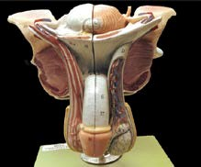
Exercise 1: Using Figures 27.7, 27.10, and 27.11 in your Saladin text, we will identify organs of the male reproductive system on the isolated models (not the full torso models) of male reproductive organs in a sequence that follows the pathway of sperm. Remember: “right” and “left” refer to the person (or parts of a person) being examined, never the observer’s right or left.

Identify the testis or testicle in the skin-covered sac called the scrotum. A part of the scrotum is shown on each half of the model, and a part of the medial partition between the testes is shown on the right side. The testis on the left side of the model is shown with its surrounding membranes removed, exposing the tunica albuginea that surrounds it.

The epididymis can be seen superior and medial to the testis on the left side. It is held tightly against the testis by a complicated set of membranes that surround both organs. The pink vas deferens can be seen attached to the inferior, medial tail of the epididymis.

Questions for discussion:

What artery supplies blood to the testicle on each side?

The testicles develop within the abdomen of the fetus, then descend into the scrotum. When does this occur?

What changes occur in sperm as they pass through the epididymis? What would happen if the epididymis could no longer carry out this function?

Next, find the spermatic cord on this model. It is a complicated structure that contains the vas deferens, a network of veins and arteries, a nerve, and some other structures. The spermatic cord continues upward and passes through the inguinal canal, a reinforced opening through the lower abdominal wall. On the right side, parts of the abdominal wall are removed so that the passage of the spermatic cord through the inguinal canal can be followed.

The sperm-transporting structure within the spermatic cord is the vas deferens, also known as the ductus deferens. Trace this muscular tube from its origin on the epididymis, through the spermatic cord, through the inguinal canal and into the abdominal cavity. From the inguinal canal, trace it across the superior surface of the bladder, over the ureter (another pink tube) and down the posterior surface of the bladder to where it joins with the seminal vesicle.

Now split the model in half and remove the left side of the bladder and attached structures. The seminal vesicles can again be located on the posterior surface of the bladder. Each seminal vesicle is a multi-lobed gland whose duct joins with the vas deferens. Inferior to the seminal vesicle and bladder, find the prostate gland. Note that the urethra passes through it. The tiny ejaculatory duct does not show up well on this model, but may be seen in Fig. 27.10. It originates where the seminal vesicle and vas deferens merge and is contained within the prostate gland. Its termination in the urethra is shown inside the prostate gland.

Questions for discussion:

Which tube is cut during a vasectomy?

Where is this tube most easily isolated to be identified and cut?

What happens to the sperm after a vasectomy, since their movement through this tube is blocked?

Besides this tube, what other structures are found in the human spermatic cord?

What percentage of human semen consists of fluids produced by the prostate and seminal vesicles?

What percentage of it consists of sperm?

What do the fluids produced by the seminal vesicles and prostate contain?

Where are sperm "stored" before ejaculation?

Find the three parts of the urethra on this model.
The prostatic urethra runs through the prostate gland.
The membranous urethra is a short segment between the prostate gland and the base of the penis.
The spongy or penile urethra is the segment of the urethra inside the penis.

Note the position of the base of the penis near the prostate gland. The spongy urethra traverses the entire penis through a column of spongy erectile tissue called the corpus spongiosum.

The penis originates near the prostate gland. Note that the proximal root of the penis runs through muscles and ligaments, and only the distal, pendulous shaft of the penis extends from the surface of the body. The expanded distal end of the penis is called its glans, which is covered by the prepuce or foreskin (commonly removed in infant males by circumcision). During erection, the erectile bodies fill with blood and cause the shaft of the penis to align with the internal, more proximal root - notice in Figure 27.10 and on the model how this would occur.

Exercise 2: Examine the torso model in which male genitalia can be inserted or removed. With these in place, identify each of the structures described in Exercise 1 above. Note the location of the bladder and reproductive structures near it relative to the intestines and other abdominal organs.

Exercise 3: In the space below, trace the pathway of sperm from where it is produced in the testes to where it exits through the glans of the penis during ejaculation. One possible difficulty you might encounter is the role of the seminal vesicle. Sperm never pass through or enter this gland. It merely produces a mucus secretion that contributes to the formation of semen.

HISTOLOGY OF THE MALE REPRODUCTIVE SYSTEM

Exercise 4: Under low power of the microscope, examine slide #12. This shows a portion of a testis.
Identify the tunica albuginea and connective tissue septa that separate the testis into lobules (see Figure 27.9 in Saladin). Notice most of the testis consists of seminiferous tubules that have been cut in many different orientations as they coil within each lobule.
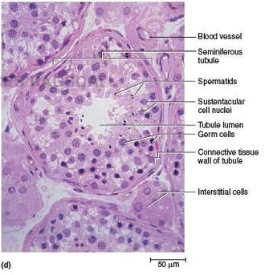
Switch to high power and examine the seminiferous tubules (Figure 27.9 in your Saladin text). Note the large cells on the outside of each tubule, with smaller cells toward the center. As sperm develop and mature they move from the outside, just deep to the tunica albuginea, to the inside of each tubule. In most of the tubules you should be able to identify the tails of sperm. These sperm are almost ready to be released into to lumen, and you may be able to see some that have already been released.

Identify interstitial cells (i.e. Leydig cells) in the spaces between the seminiferous tubules. These are the cells that respond to LH to produce testosterone.

Questions for discussion:

Development of sperm in the seminiferous tubules is stimulated by which hormone from the pituitary gland?

Secretion of testosterone by the interstitial cells of the testis is stimulated by which hormone from the pituitary gland?

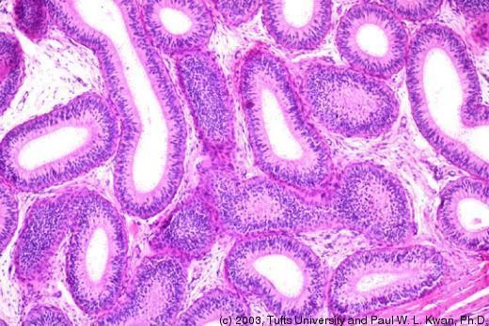
Exercise 5: Under low power of the microscope, examine slide #29 of the epididymis. Note the appearance of many tubules in the center - this is actually a single tube tightly coiled up and thus cut many times on this slide. Superficially, note the dense irregular connective tissue which surrounds the epididymis. This contains many blood vessels, reflecting the large blood supply that this organ has.

Switch to higher power and examine one or two of the sectioned tubules. These are lined by a pseudostratified columnar epithelium supported by a looser connective tissue in which many smaller blood vessels are evident. In some regions of the tubules you will note sperm.

Question for discussion:

What is the function of the epididymis?

Questions for discussion:

What causes the erectile bodies of the penis to fill with blood during erection?

Why does the erect penis assume the angle it does (pointing somewhat superiorly)?

GROSS ANATOMY OF THE FEMALE REPRODUCTIVE SYSTEM
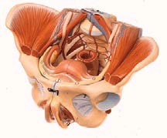
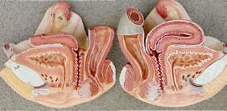
Exercise 7: Use the independent plastic model of the female pelvis (not the torso model) for this section. Figures 28.1, 28.3, and 28.8 in your Saladin text will serve as references. On the midsagittal view of one-half of the model, locate the rectum, anus, urinary bladder, urethra and urethral opening and note their positions relative to the uterus, vagina and vaginal opening.

Identify the ovaries on each side of this model. Two tubular structures connect the ovary to the uterus. The inferior one is a ligament that helps support the ovary. The pink/red one, with the expanded end near the ovary, is the uterine tube, also called the oviduct or Fallopian tube. The expanded, funnel-like end of the uterine tube, which partly surrounds the ovary, is called its infundibulum. Finger-like fimbriae can be seen attached to the edge of the infundibulum. Proximal to this (nearer the uterus) is the ampulla, then the narrower isthmus of the oviduct that penetrates the wall of the uterus.

On Figure 28.3 of your Saladin text, identify the infundibulum, fimbriae, ampulla, and isthmus of the uterine tube.

On the model, examine the uterus which consists of three parts. The fundus of the uterus is superior to the entry point of the uterine tubes. The middle, and largest region of the uterus is the body. The third, most inferior part of the uterus is the narrow cervix which projects inferiorly into the vagina. The recessed grooves between the cervix and vaginal wall (like a moat around a castle) are called fornices (singular = fornix). Find the position of the anterior fornix and the posterior fornix.

Internally, note that the uterus shows two different textures and colors. The thinner striated zone on the inside represents the endometrium. External to this is a thicker, lighter red layer called the myometrium. The smooth, pink outermost layer is its serosa.

Most of the time, the uterus lies in the position shown on this model - tipped anteriorly to rest on the superior surface of the urinary bladder. It assumes a more upright position during orgasm and during pregnancy. Between the uterus and bladder is a peritoneum-lined vesicouterine pouch (not open on the model.) Between the uterus and rectum, find the rectouterine pouch. These two pouches are of medical significance because they are "low points" for the drainage of abdominal cavity infections. Note that the rectouterine pouch can be easily drained through the vagina by means of an incision in the posterior fornix.

Re-assemble the model, placing the inner piece inside the rest of the pelvis so you can examine the external genitalia. Note both the urethra and vagina open into a narrow space called the vestibule, while the anus opens much more posteriorly. Lateral to the vestibule are two folds of skin on each side. The inner, smaller folds are named the labia minora (“small lips”). Lateral to them are thicker folds called the labia majora (“large lips”).

At the anterior part of the vestibule between the two labia minora, identify the clitoris. This develops from the same embryonic structure in the female as the penis in the male, and it also consists of erectile tissue that fills with blood during sexual excitement. Near the opening of the vagina, a small, horizontal fold of mucous membrane represents the hymen. The vestibule, labia majora and minora, urethral and vaginal orifices, hymen, and clitoris are collectively called the vulva or the pudenda.

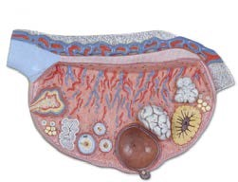
Exercise 8: Place the female genitalia into the appropriate torso model. Identify the structures described above. Note the location of the bladder, uterus, ovaries, and oviducts relative to the intestines (including the rectum) and other abdominal organs.

Exercise 9: Examine the model representing half of an ovary with different stages of development of the follicles. At the middle bottom is a mature or vesicular follicle that is in the process of ovulation: rupturing to release its egg, or oocyte (sometimes, although not quite correctly, called the ovum). To the left of the mature follicle is a large, yellow, scalloped structure, a corpus luteum (“yellow body”). It formed from a previously ovulated mature follicle. Between the mature follicle and corpus luteum is one of three corpus albicans
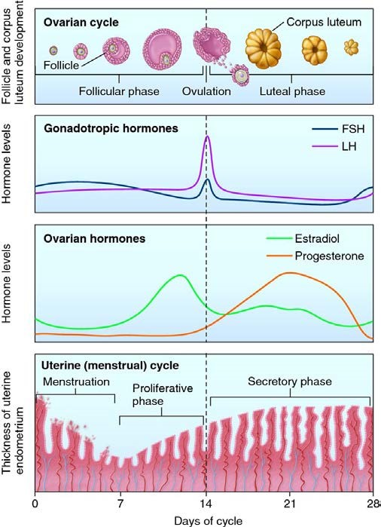
(“white body”). These are the remnant scars of previous corpora lutea (that’s the plural of “corpus luteum”). To the left of the mature follicle are three medium-sized, immature, secondary follicles that may someday become mature follicles. With the aid of Figure 28.2 in your Saladin text, be sure you can identify these structures.

Exercise 10: Examine the figure shown here (this is similar to figure Figure 28.14 in your Saladin text) which correlates the phases of the ovarian cycle and the phases of the menstrual cycle. Identify what is happening in the ovary during its follicular phase, ovulation, and luteal phase. Identify what is happening to the endometrium of the uterus during its menstrual phase, proliferative phase, and secretory phase.

Questions for discussion:

The early stages of follicle development, before ovulation, occur under the stimulation of which hormone from the anterior pituitary gland?

During which part of the menstrual cycle is this occurring?

The conversion of a follicle to a corpus luteum, after ovulation, occurs under the stimulation of which hormone from the anterior pituitary gland?

During which part of the menstrual cycle is this occurring?

If the oocyte is fertilized by sperm, where (which part of which organ) in the female reproductive system will this occur?

During which part of the menstrual cycle is this most likely to occur?

HISTOLOGY OF THE FEMALE REPRODUCTIVE SYSTEM

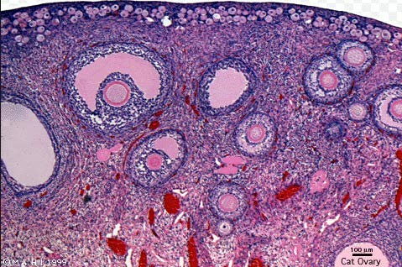
Exercise 11: Examine slide #40 of the ovary under low power. This slide is not from a human - it is from an animal that gives birth to many young at a time since it shows many follicles developing simultaneously. Identify its cortex, medulla, and tunica albuginea. Identify follicles in different stages of development, including large fluid-filled mature follicles. Identify a corpus luteum, in which cells have filled in the central region of the follicle.

CANCERS ASSOCIATED WITH SEX ORGANS:
The prostate gland is a common source of cancer in males, in fact almost every male will develop prostate cancer if they are fortunate enough to live long enough. With that stated, some prostate cancers are quite aggressive and early diagnosis is essential for continued good health. In cancer, as the cells of the prostate divide, the swollen gland can pinch the urethra making it hard to empty the bladder. There are additional symptoms can including pelvic pain, blood in urine or erectile dysfunction. Furthermore, because the nerves responsible for sexual function (erection) are often damaged or cut during a prostectomy (cancer removal), men are often hesitant to report the condition to their care provider or seek aggressive treatments. Treatment often also involves removal of testosterone (testosterone) which can make men fearful of changes to their identity and masculinity. This too can make an individual less likely to treat the condition until the cancer has metastasized. Denial of a health condition is difficult to treat.

In Contrast: Breast cancer affects primarily women, in fact it is the most diagnosed cancer in women. Risk factors for developing breast cancer are quite varied, but range in having a genetic predisposition, to diet and exercise. Early detection of abnormal cell masses can include treatments like lumpectomies (removal of the lump) and subsequent radiation or chemotherapy, to more invasive treatments like mastectomies (removal of breast). Individuals with this cancer can also experience a powerful sense of denial because of perceived changes in identity once a breast(s) is removed. Reconstructive surgery is a frequent accompaniment to mastectomies. (However more women are opting out of additional surgery every year.) There are several types of breast cancer, all of which can be detected with annual mammography and monthly self-breast exams.

Identification of either cancer early, and making an effort to seek effective treatment for the condition is important for improving long-term survival.

Prostate Cancer At a Glance: https://seer.cancer.gov/statfacts/html/prost.html
Estimated New Cases in 2017 161,360 % of All New Cancer Cases 9.6%
Estimated Deaths in 2017 26,730 % of All Cancer Deaths 4.4%

Female Breast Cancer At a Glance: https://seer.cancer.gov/statfacts/html/breast.html
Estimated New Cases in 2017 252,710 % of All New Cancer Cases 15.0%
Estimated Deaths in 2017 40,610 % of All Cancer Deaths 6.8%

NAME:_____________________(type or write in the blank)
REPRODUCTIVE SYSTEM LABORATORY REVIEW Questions: 10 points
CUT-PASTE this assignment into a separate Microsoft Word file and write or type the answers in that document. Submit the document to D2L when you are finished.

1) Write a minimum of 15-25 words to describe each of the following items:
Identify the organs of the human reproductive system, both male and female
a) Describe the functions of these reproductive organs
b) Describe the histology of the testis, epididymis, penis, ovary, and uterine tube
c) Correlate the physiological phases of the ovary with those of the uterus
d) Describe the pathway of sperm from their production in the testicles until they may fertilize an oocyte, and the pathway that the resulting embryo will follow to the uterus.

2) Compare and contrast the following with a minimum of 15-25 words:
a) The ovary and testicle with respect to the hormones and haploid cells they produce
b) Mitosis and Meiosis and how these two kinds of cell division differ (Saladin has some excellent illustrations of these two processes)

3) With respect to the uterine (menstrual) cycle and the follicle, describe the phases and changes in hormones that control this process with 35-45 words (a diagram might also help)

4) With respect to Breast cancer and Prostate cancer talk to a person by phone (to honor social distancing needs) who has been screedned or treated for one of these kinds of cancer (you could ask your parents or others for help finding someone). Ask about the experience and find out their age and risk status. Write 30-40 words about their expereince.

