Biology 212: Anatomy and Physiology II
Lab #4: CARDIOVASCULAR PHYSIOLOGY AND THE ELECTROCARDIOGRAM
References: Saladin, KS: Anatomy and Physiology, The Unity of Form and Function 7th (2015). Be sure you read and understand Chapter 19 before beginning this lab.

Overview of the Cardiovascular System:
Our heart is an amazing organ that pumps blood throughout our bodies our entire life. If your heart beats 72 times a minute for 78 years, you will have a heart that has beat/contracted approximately 3 billion (3,000,000,000) times. How does the heart work? If it is injured or damaged at some point, how will your physician, a cardiologist, diagnose what is wrong and strategize ways to improve the health of your heart or prescribe exercise after a heart attack (cardiac rehabilitation)? Electrocardiograms (ECGs) provide important information about the function of your heart. In this exercise, you will learn the fundamentals of the electrical activity of the heart and relate these activities to the mechanical actions of pumping. You will also become familiar with your peripheral circulation and how it is dependent on a beating heart and patent/open vessels.

The circulatory system encompasses the heart, blood vessels, and blood contained in this closed system. As seen last week’s in lab, the system is vitally responsible for delivery of oxygenated blood to the body and the delivery of carbon dioxide rich deoxygenated blood to the lungs. There are two sets of arteries, low pressure pulmonary trunk (pulmonary circuit) and high pressure aorta (systemic circuits), that deliver blood to the lungs and body respectively. Each division is really a pressure reservoir to maintain the pressure gradient generated by the pumping of the heart during systole and eject blood into these vessel pathways. Perfusion of the cardiac tissue, via coronary circulation, occurs during diastole. Your pulse is evidence of the blood pressure generated during systole and the bolus of blood ejected into the aorta and well as the resultant perfusion into your finger.

Objectives:
1. Compare and contrast values for a normal heart rate with tachycardia and bradycardia.
2. For a volunteer determine pulse rate by palpating the radial artery and with a finger pulse transducer
3. Describe the origin of cardiac autorhythmicity and the major landmarks of the conduction pathway within the heart.
4. Define what ECG stands for, and how the ECG is generated in terms of a change in voltage (mV) and time (seconds).
5. Label features of the ECG (P-QRS-T waves) and how the waves correlate with the mechanical events of the cardiac cycle and the events occurring in the conduction pathway.
6. Compare and contrast intervals verses segments on an ECG in this regard.
7. For a volunteer use the ECG, Lead I, and five R-R intervals to determine heart rate.
8. Compare and contrast these clinical terms: nodal sinus rhythm, arrhythmia, heart block, and fibrillation

Manual determination and interpretation of pulse rate

Heart rate at rest should fall into the range of 55 to 85 beats/minute. A heart rate over 100 beats per minute is usually considered to be tachycardia (fast). A heart rate under 60 beats/minute is usually considered to be bradycardia (slow). If you are exercising, your oxygen demands increase and the heart rate and cardiac output increases to supply more blood and oxygen to your exercising muscles. At such times, an elevated heart rate is normal. If you are an athlete or sleeping, a low heart rate is normal. Any heart rate above 200 BPM is never safe even when exercising, and a pulse as low as 40 BPM is never safe.

For the following exercises, we will be using a data acquisition system to collect clinical information about you and your lab partners. These exercises will be carried out using your lab instructor’s computer connected to the data acquisition system. The exercises will be run as demonstrations for groups of 4-6 students. You will receive a hard copy of your group’s information.

Exercise 1a : Palpation of radial arterial pulse rate.
This exercise assumes that when the heart depolarizes and contracts it creates an ejection volume of blood that leaves the ventricle. This volume creates a pressure wave as the blood moves distally from the heart into systemic circulation. When the waves arrives at your wrist it can be felt by putting light pressure on the radial artery.
1. Select a volunteer from your group of 4-6 students and locate the radial artery or ulnar artery in the wrist. (Usually the ulnar pulse is the harder to find.)
2. Apply firm pressure over the radial artery so you can feel pulses. Count the number of pulses in 15 second and calculate the number of pulses per minute:
(_________pulses/15 seconds X 60 seconds/minute = ________ pulses/ minute).

Exercise 1b: Determination of pulse with a pulse transducer.
The pulse transducer is a plethysmograph that fits over your finger and detects the movement/pulse wave of blood traveling through small arteries in your finger. This pressure wave is detected and converted to a voltage change that can be recorded by the system. Note the distribution of arterial blood flow of the hand. Fingers receive blood through the superficial palmar arch as well as through the deep palmar arch from both the radial and ulnar arteries. This same pulse wave then travels into the end of your fingers. Your instructor will record this data for your group’s volunteer.
1. Place the nickel-sized pressure pad of the pulse transducer on the tip of the middle finger of either hand of the volunteer. Use the Velcro strap to make sure it is firmly attached but not tight enough to cut off circulation. Rest this hand in your lap with the palm up.
2. Instructor will start recording. Remind the volunteer to remain relaxed and as still as possible. Make sure the volunteer is still facing away from the monitor. BE SURE to observe that the x-axis, horizontal axis, represents time (cm/second or box/second), you will need to understand this scale to determine the pulse rate.
3. Highlight a record that includes a minimum of five pulses and print the results. Determine the pulse rate (beats/min) on this tracing, using this formula:
( 5 pulses/__________ seconds X 60 seconds/minute = ________ pulses/ minute).
4. While recording with the finger pulse transducer, put pressure on the radial artery. Observe that the amplitude (size) of the finger pulses becomes diminished until the pressure on the radial artery is removed.

Did the numbers for your pulse rate obtained by the radial pulse method agree with those of the finger pulse transducer? Explain your answer.

How did compression of the radial artery affect blood flow to the finger? Explain your answer.

Cellular Origin of Depolarization and the Cardiac Conduction System.

All vertebrate hearts are said to be myogenic. (Break the word apart, and you will understand its meaning. The root myo- means muscle, and in this case, it means the heart muscle proper is involved. The second part of the word -- genic -- means origin. The heart is the source of the signal to contract; it does not rely on a stimulation from axons originating in the nervous system like a skeletal muscle does, nor does it rely on endocrine signals for signal initiation. Indeed during a heart transplant surgery a heart is removed from one person, and continues to beat with no neural inputs at all during and after placement in the second organ recipient. However, both the nervous system and the endocrine system (as well as some chemicals) can modify the heart rate.

The bulk of the myocardium represents the layer of contractile muscle cells in the heart that generates the contraction force to push blood through the pulmonary or systemic circuits. Autorhythmic cells, conduction cells, depolarize spontaneously without external stimulation and create the action potential that the contractile cells need to function. In a healthy heart the cells of the sinoatrial (SA) node are quite permeable to sodium, such that when enough sodium leaks into the sarcoplasm, voltage-gated sodium, calcium and potassium channels sequentially open creating depolarization followed by repolarization. This pacemaker depolarization in the SA Nodal cells passes through gap junctions that link every cell of the heart into an electrical syncytium. There is a very specific pathway that a depolarization must follow, deviations or alterations in this pathway can be fatal. Any abnormal depolarization in the cells of the heart is called an ARHYTHMIA.

Exercise 2. Landmarks of the Cardiac Conduction System:
Obtain one of the large brown heart models with the conduction system outlined. (You probably looked at this model last week when identifying the features of heart anatomy.)
Yes heart anatomy will also be on Lab Exam #2 Review Your Heart Anatomy

1. The pacemaker of the heart is the sinoatrial (SA) node; #73) located close to where the superior vena cava empties into the upper right atrium. It is a green spot on the upper surface of the right atrium.
2. When the SA node depolarizes, its sends its wave of depolarization through the gap junctions to adjacent and ever more distal cells laterally over both atria and obliquely permitting the atria to depolarize, contract, and eject blood through the AV valves into the ventricles. the AV Node. The atrioventricular (AV) node; #74) s located on the lower medial floor of the right atrium/atrioventricular septum and represents the location where the depolarization can pass from atria into ventricular septum.
3. After the AV node the depolarization travels into the atrioventricular bundle (i.e., Bundle of His, #75) on its pathway down the septum towards the ventricular myocardium.
4. The atrioventricular bundle passes into the interventricular septum and branches into right (#76) and left bundle branch (#77) that deliver the wave of depolarization into the right or left ventricles respectively.
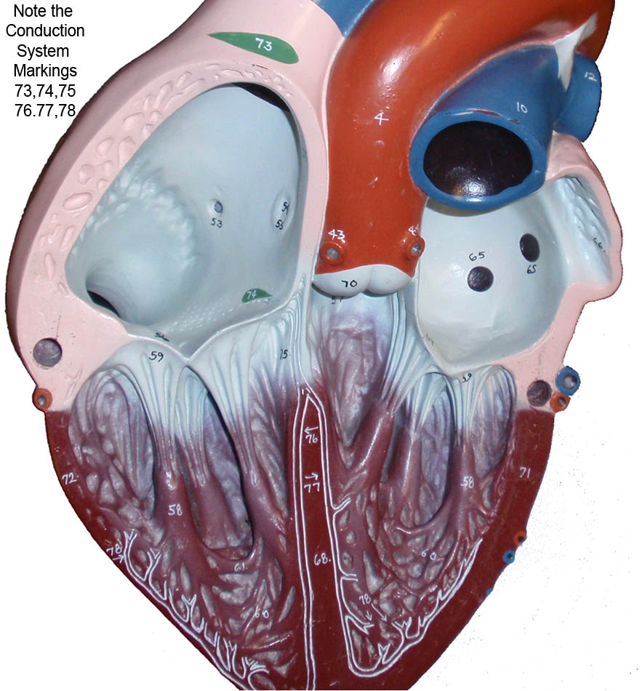
5. The bundle branches divide into fine Purkinje fibers (#78) in the septum along the left bundle branch and after the apex of the heart. These fibers distribute the wave of depolarization to the individual contractile cardiomyocytes where contractile force for ventricular ejection is finally generated.
6. The wave of depolarization moves in a superior direction until it reaches the atrioventricular septum, which “should” prevent passage of the depolarization back into the atrium.
7. The wave of depolarization is followed by a wave of repolarization and cardiac rest (diastole) making the cardiac cells ready to receive the next depolarization for the next heart cycle. It is important to remember that perfusion of heart tissue (oxygen delivery) occurs mostly during diastole.

The Electrocardiogram (ECG)
The electrical waves of depolarization and repolarization that spread across the heart can be detected on the surface of the skin. The output, or record of cardiac depolarization across time is a graph called an electrocardiogram (ECG or EKG). The sum of changes in the electrical currents (in millivolts) of the cardiac cells is detected on the surface of the body as a function of time. This means the time variable is plotted on the x axis and the voltage difference (mV) is on the y axis.

An ECG is the electrical recording from a positive (+) and negative (-) electrode. The connection between the two electrodes is called a lead. If the depolarization wave (summation of all cardiac cell potentials) is moving from the negative electrode towards the positive electrode, the record will produce a positive or upward ECG deflection. As the depolarization departs but reaches the second electrode, the signal will again return to baseline. When the signal is moving towards the reference electrode, the recording will be a negative ECG wave deflection. If the wave of depolarization moves perpendicular to the positive and negative electrodes it is called isoelectric (no net positive or negative ECG deflection).

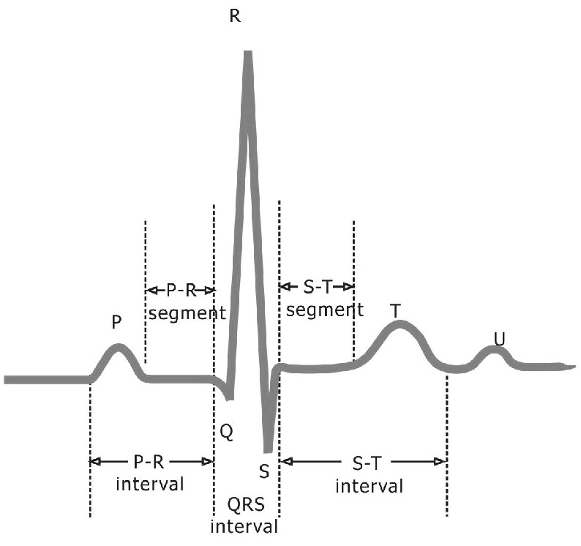
The normal ECG has a series of distinct waves called deflection waves (P wave, QRS complex and T wave). Each part of the ECG represents a specific electrical event in the ventricle. In general, the first wave deflection generally observed on the ECG is the small P wave and is produced when SA node causes the right and then the left atria to depolarize. The wave of depolarization is the electrical signal from the contractile cells to begin to initiate contraction, but this wave does not indicate that the atria have actually contracted to pump blood into the ventricle. The QRS complex represents ventricular depolarization and the T-wave represents the electrical signature of ventricular repolarization.

More Specifically: The QRS complex consists of three deflections.
-The first negative deflection from baseline due to ventricular depolarizationion is called the Q-wave.
-The first positive deflection from baseline due to ventriclventricualr depolarization is called the R-wave.
-The first negative deflection after the R-wave is called the S-wave.
-NOTE:If there is no observed Q-wave you may observe a RS only. If there is no positive R-wave, the negative deflection is called a Q-wave. What you see is a reflection of the depolarization pathway in the heart, the heart’s orientation in thorax, and the size of the myocardium.

The QRS complex marks time required for the ventricles to completely depolarize. Larger wave sizes (i.e., large voltage amplitude change) wave are caused by either a larger muscle mass of the ventricles or the fact that the wave of depolarization is moving directly towards the electrode. The QRS complex is typically about 0.08 seconds in duration. IT IS VERY IMPORTANT to remember that depolarization (QRS) come BEFORE myocardial contraction. IT IS ALSO very important to remember that just because the heart depolarizes, blood need not be ejected into the pulmonary artery or aorta (ECG rate does not always equal the pulse rate!). Ejection (cardiac output) requires that the pressure inside the ventricle is greater than in the aorta or pulmonic trunk, AND that the semilunar valves are able to open properly.
The T wave is the final noteworthy deflection on the trace. This wave marks the change in voltage created by ventricular repolarization.

The ST segment corresponds to the time when calcium has entered the cardiac myocytes and the ventricles are contracting. It is calculated as the time from the end of the QRS (perhaps only a Q) and the start of the T-wave. As a general rule the longer the ST-segment, the more time is spent generating ventricular force and the more blood can be ejected (increased cardiac output).

The PR segment corresponds to the time the atria are depolarizing relative to passage through the AV Node and entry of the depolarization in the ventricle.
(typically about 0.16-0.18 sec).

The R-R interval represents the time between ventricular depolarizations. It is one of the most important measures. If your heart rate is 60 beats/minute, then the R-R interval is 1 second. If the average RR interval of five cardiac cycles was 0.5 seconds, the heart rate would be 120 beats/minute (1 beat/ 0.5 sec X 60 seconds/minute = 120 beats/minute or tachycardia). If the RR-interval was 2.0 seconds the heart rate would be 30 beats/minute (1 beat/ 2.0 sec X 60 seconds/minute = 30 beats/minute or bradycardia).

The S-T interval is the time from the end of ventricular depolarization to the end of the T-wave. Diastole or a phase of ventricular rest follows this interval.
The QRS interval is the time required to initiate and complete ventricular depolarization. If a person have faulty bundle branch (bundle branch block) this process is slower than usual and the QRS would be too long.
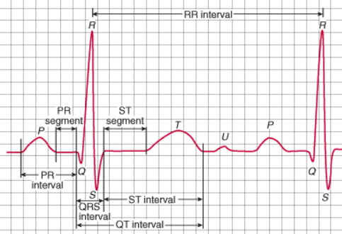

You might assume the atria do not go through repolarization based on the above description, but that would be the wrong assumption. The atria do repolarize, however the mass of the atria is very small relative to the mass of the ventricles and this electrical repolarization event is obscured (hidden) by the depolarization of the ventricles and the QRS complex.

The appearance of the ECG is also a function of where (anatomically) the reference and recording electrodes are placed, this permits the evaluation of electrical changes across each very specific axis. Each pair of location is called a LEAD, and there are many different leads that can be used clinically. Einthoven's triangle represents three (I, II and III) when the positive and negative electrodes are placed two these three locations (right shoulder, left shoulder or left hip). These are the three most basic leads used clinically, although if you study to become a cardiac rehabilitation specialist you will learn many more. These three axes approximates an equilateral triangle with the heart at the center.
Lead I: negative on right shoulder, positive on left shoulder
Lead II: negative on right shoulder, positive on left hip
Lead III: positive on left hip, negative on left shoulder

For a patient in a bed at rest, lead I is post popular because they can move about relatively freely and it is easy to determine if the electrodes are attached properly. We will use primarily Lead I later in this lab activity. Remember that electrolytes in the body conduct electricity freely so placement of an electrode in the left hip will look just like it would in the left knee or the left foot.
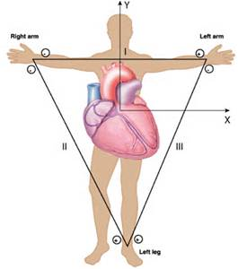

Exercise 3: Look at the recording below and examine the sample finger pulse (top tracing) and ECG (bottom tracing) to see how calculations are made. Note that the X-axis across the bottom of these recording shows how each parameter changes across time (seconds). Remember to convert events per second to events per minute and to base estimate on an average of five values. Also remember that ECG Q-waves are not always observed. Your instructor will show you how to calculate these values using a ruler or with the box method.
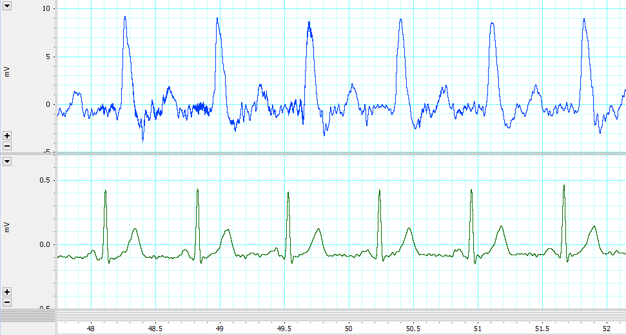

Pulse Rate: RR-Interval: Heart Rate: PR-Segment: ST-Interval: .

Heart Block and Fibrillation:
Heart Block is a failure to properly transmit the wave of depolarization through any part of the conduction system. Heart block is a pathological condition resulting from an inability to enter or exit the AV node or to pass through the Bundle of His or Bundle Branches. Heart block usually results from disease. Damage to any of the above elements of the conduction system can lead to a heart block. Normal healing of any damage causes cardiac muscle to be replaced by connective tissue, and connective tissue is not autorhythmic and does not readily conduct action potentials. So the damage can be permanent to the conduction system. Total heart block is when the signal from the atria to the ventricles is blocked completely—your SA node is no longer the pacemaker for the ventricles. With total heart block the authorhythmicity of other slower secondary pacemaker cells in the heart (i.e. AV node or apex) determines the heart rate and the heart rate becomes very slow (20-40 beats per minute).

Fibrillation, by contrast, is anarchy in the heart chambers where the wave/pathway of depolarization and contraction is random and unorganized. If it occurs in the ventricles, no blood would be pumped to the body (i.e., brain) resulting in unconsciousness and potential death. Both conditions, heart block and fibrillation, can be easily detected by the ECG (electrocardiogram). If you observe an apparent fibrillation pattern in any ECG you look at, ALWAYS double check to see that your electrodes are all firmly attached to your volunteer or clinical patient. These data collection systems can and do pick up electrical interference, so if the patient has lots of static electricity in their clothes or metal jewelry you may not be able to collect a clean ECG recording.
Normal Sinus Rhythm ECG Fibrillation (Saw Tooth ECG Pattern) Convert to Normal ECG

Exercise 4. Collect simultaneous Finger pulse and ECG trace for your group’s volunteer. Identify the wave deflections on your trace. You should also be able to determine separate RR intervals (average of 3 R-Rs is good enough for the lab exam, average of 5 will give you a more clinically accurate value) and determine an average heart rate (beats/minutes) using either a ruler or the box method. Your lab instructor will show you how to measure heart rate in lab. On the lab exam you will be able to choose the method (box or ruler) that you wish to use for your calculations, both tools will be available on the test. You also need to determine and interpret the PR intervals and the ST intervals (seconds).

Your instructor will collect a ECG and Finger Pulse data for each group as a series of demonstrations in this lab and provide each group with a paper recording so they can perform the desired measurements.
1. Connect each electrode lead (white, black, green) to the electrode gels. Place the electrode gels on the wrists and ankle of the volunteer: positive lead (black) on left wrist, negative lead (white) on right wrist and ground (green) on right ankle or abdomen. This is the standard electrode placement for Lead I on the ECG. Attach the finger pulse transducer to their finger with the palm facing up.
2. Start recording and adjust electrodes until a suitable ECG and finger pulse record is obtained. Remind the volunteer to remain relaxed and as still as possible throughout the duration of the sampling period.
3. Highlight the ECG trace, and print off the results.

Exercise 5. For additional lab exam practice fill in this table using these three ECG recordings. You can do this when you study the lab materials at home. Describe the rate (beats/minute) of these three patterns shown below with respect to representing a normal sinus rhythm (every QRS complex follows a P-wave, P-waves are same size and shape), tachycardia or bradycardia. (X-axis represents seconds and Y-axis represents millivolts)
 | RR interval (sec) | PR interval (sec) | ST interval  (sec) | Heart Rate  Beats/minute | Clinical Term for Rate
ECG# 1

ECG #2

ECG #3

Your ECG
Values

ECG 1 | 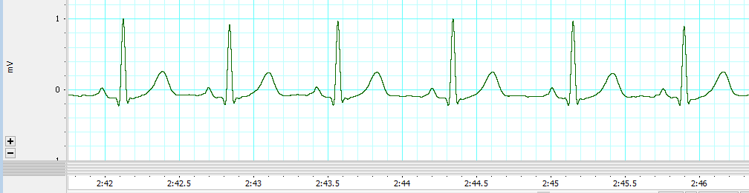
ECG 2 | 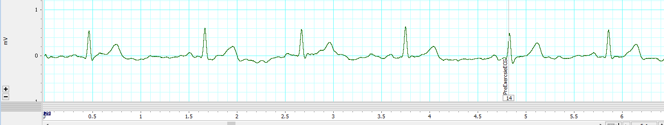
ECG 3 | 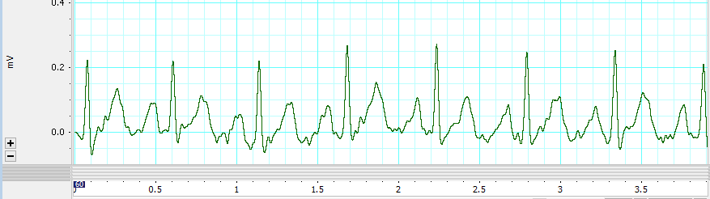

Exercise 6. Discuss the following physiological problems with your lab partners so you can better understand how ECGs are used to explain cardiovascular function.

With respect to the P, QRS, and T waves: When does peak ventricular force and ejection of blood into the pulmonary trunk or aorta occur?

When does cardiac perfusion occur? If you compare ECG #2 to ECG #3, when the heart rate increases what is decreased more, the time between T and QRS (diastole), or the time between QRS and T (systole)?

Why does tachycardia during exercise often exacerbate hypoxia in the heart and lead to conduction problems, fibrillation or a heart attack?

Does the electrical depolarization event precede the arrival of the blood pulse distally at the finger? Consider a person with a long arm (six foot tall WSU Women’s Basketball player) compared to an individual with the arm of a five foot tall WSU Gymnast. Would the delay between ECG and pulse wave arrival in the finger for the tall person be shorter, longer or the same relative to the tall person? Why?

Why should the clinician NEVER consider atrial depolarization rate as a measure of heart rate? Does ventricular depolarization always follow atrial depolarization? What is the best term to describe this aberration: Arrhythmia, Heart Block or Fibrillation?

Consider the situation where the left AV Valve did not open properly during diastole (stenosis) so that little ventricular filling occurred, and the mostly empty ventricle contracted during systole without ejection into the aorta. Why would you see ventricular depolarization on the ECG but observe no pulse in the finger? Now consider why the clinician always needs to verify that heart depolarization rate is the same as pulse rate? Why is it easier to monitor heart depolarization rate rather than pulse rate in a hospital intensive care?

REVIEW CHECKLIST OF PARTS OF THE HEART and Content for Lab Exam #2
Base | Apex | Anterior/Posterior | Left/Right
Anterior interventricular sulcus | Tricuspid or right atrio-ventricular valve | Atrio-ventricular valve flap | Circumflex branch of left coronary artery
Right auricle | Pulmonary semilunar valve | Chordae tendinae | Anterior interventricular artery
Left auricle | Pulmonary trunk | Papillary muscles | Posterior interventricular artery
Right atrium | Pulmonary arteries | Epicardium or visceral pericardium | Sino-atrial node
Left atrium | Pulmonary veins | Endocardium | Atrio-ventricular node
Right ventricle | Bicuspid or left atrio-ventricular valve | Myocardium | Atrio-ventricular bundle  Bundle of His
Left ventricle | Aortic semilunar valve | Interventricular septum | Rt/Lt Bundle Branches
Superior vena cava | Aorta | Interatrial septum | Purkinje Fibers
Inferior vena cava | Semilunar valve flap | Right and left coronary arteries (origin on aorta) | T.Q. Above Bold on Large Heart Model Only!
If you passed a string through the vena cava to the pulmonary artery, could you name all the structures it crosses?
If you passed a string through the pulmonary artery to the aorta, could you name all the structures it passes over?

