Biology 212: Anatomy and Physiology II

Lab #6: Respiratory Physiology in Health and Disease

References: Saladin, KS: Anatomy and Physiology, The Unity of Form and Function 7th (2015)

Be sure you have read and understand Chapter 22 before beginning this lab.

INTRODUCTION:

Of the many processes occurring in our bodies, those that function to move oxygen to the tissues and return carbon dioxide to the lung are among the most important. If tissues are deprived of oxygen (hypoxia) for too long they undergo injury (ischemia) and may undergo cellular death (infarct). Infarct is the core problem related to stroke, heart attack, and gangrene. Oxygen deprivation time factor is especially critical for the cells of the heart and brain which have a very delicate balance between oxygen demand and oxygen delivery. The heart, lung and blood all work together to ensure that oxygen is delivered to the body. Failure of anyone part of this triad is fatal.

We have spent several labs examining the anatomy and physiology of the cardiovascular system, and have just begun our examination of the respiratory system. In lecture you have learned that the heart is a pump designed to push blood through the system. You also know that maintenance of flow of blood to the cells of the body is essential and that this is controlled by several diverse mechanisms like heart rate and blood pressure. In this lab, you will gain some insight into the controls of the respiratory system by observing a person's respiratory movements you will also learn about the ventilator volumes used to clinically characterize healthy patterns.

Learning Objectives:
Upon completion of this exercise students will be able to:
1) Measure resting breathing rate
2) Discuss anatomical and neural mechanisms that make inspiration and expiration possible
3) Discuss Boyle’s Law with respect to pressure gradients typical of inspiration and expiration
4) Understand the normal values for tidal volume, inspiratory reserve, expiratory reserve, vital capacity, FEV, ventilation rate, and minute respiratory volume.
5) Explain how Predicted ventilatory volumes are used clinically
6) Use spirometry to calculate clinically important respiratory volumes.
Exercise 1. What is the normal breathing rate and is my breathing rate normal?
Let's determine resting respiratory rates. This is best accomplished by having your lab partner count your respirations per minute. After asking for permission, gently put your hand on your lab partner’s shoulder for a minute as they relax and just breath as normally as possible. It should also be done while the person is not totally aware that you are monitoring their breathing. (You cannot count your own breathing rate because your awareness alters the rate.) Count the number of breaths that occur in a full 60 seconds. Breathing rate is typically expressed as breaths/minute and is about 8-12 breaths /min.
What was your respiratory rate? (Be sure to include the units of measure.)
Was your breathing rate faster or slower than normal? Why might this be?

Exercise 2. Review of Respiratory Anatomy:
Recall the structure of the thoracic cavity and the lungs on the torso model from Lab #5. The two lungs are each surrounded by a double membranous (serous membrane) sac called the pleura and are located in two separate pleural cavities. The lungs are suspended in these sacs on either side of the heart. The superior aspect of the thoracic cavity extend into the areas between the clavicles and scapula. The outer-most surface of the chest cavity is the thoracic wall which includes the rib cage and the associated muscles. The parietal pleura lining the pleural cavity attaches to this surface. The inferior aspect of the thoracic cavity is delineated by the diaphragm. Another portion of the parietal pleura is attached to this muscle. The visceral portion of the pleura is adherent to the surface of the lung proper.
Think of your fist embedded in a balloon. The parietal pleura is the outer surface of the balloon. The surface covering your hand is the visceral pleura, your hand represents the lung proper. A thin film of pleural fluid fills the space between the visceral and parietal pleura, this fluid is important for reducing friction between lung and thoracic wall, as well as for maintaining a slight vacuum within the pleural cavity.
Exercise 3. Using a Syringe to Demonstrate the Relationship Between Volume and Pressure
Now let's look at pressure changes in the lungs. Remember that air flows from areas of high pressure to areas of low pressure. One way to change pressure of a gas is to change the volume of its container. Think about a sealed syringe that is half-filled with air. If you pull back on the plunger, the volume of the syringe increases and the pressure inside the syringe decreases. If you were to open the seal on the syringe, air would rush from the outside into the syringe. The pressure outside the syringe was at a higher pressure than the pressure inside the syringe. Flow into the syringe stopped when the two pressures equalized. Remember that air is easily compressed, but water is not easily compressed, why is this important regarding the lung and ventilation?
Return to the sealed syringe again. If you push down on the plunger, the volume of the syringe decreases and the pressure inside the syringe increases. Now opening the seal causes air to rush out of the syringe into the atmosphere. In this case the pressure inside the syringe was greater than atmospheric pressure, so air exited the syringe. Again, flow stopped when the two pressures equalized. You may remember this as “Boyle’s Law in your high school physics class: Pressure₁ x Volume₁ = Pressure₂ x Volume₂
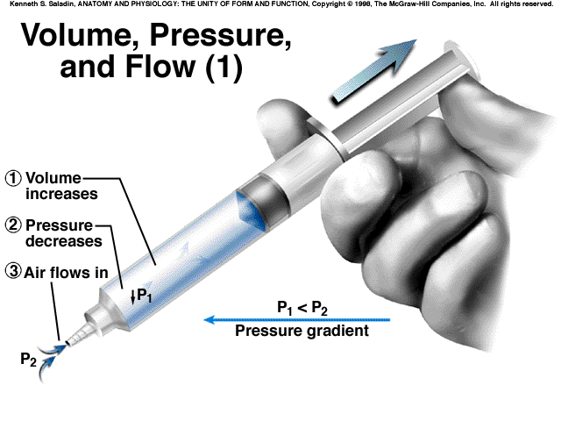 | 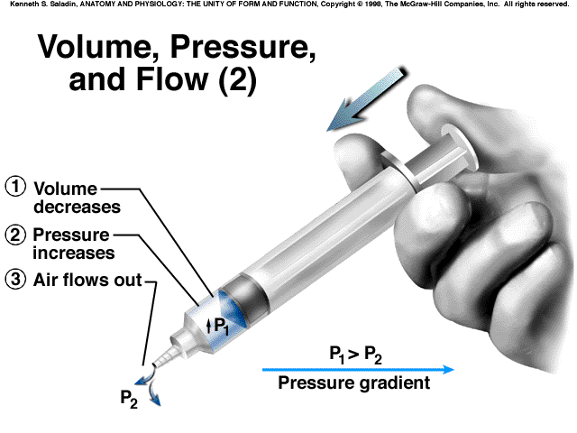
Changes in the thoracic cavity are similar, the following graph shows the volume (V) inside a sealed syringe as a function of changes in pressure (P) applied to syringe. (This is almost a linear relationship when dealing with very small pressure and volume changes meaning that you should be seeing a relatively straight line between two different pressures, P₁ and P₂.)
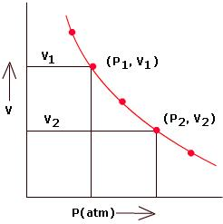
Complete the following statement concerning the relationship this graph illustrates.
As the volume (V) of a sealed container increases, the pressure (P) of the gas inside the container _______________________.
Circle the right answer.
The pressure of the gas is said to be (proportional to OR inversely proportional to)_ to the size (volume) of the container.

Look up the definition for Boyle's law in your textbook. Rewrite this definition in terms of ventilation. Consider an open or closed glottis (space between vocal cords) and closure of epiglottis, when is the lung an “Open” or “Closed” system? How does Boyle’s Law describe why air enters or leaves the lung?
The mechanical process of pulmonary ventilation is achieved by rhythmically changing the volume in the thoracic cavity (i.e., chest cavity). Changes in volume will change the pressures in a closed system according to Boyle's law. Air always flows from an area of high pressure to an area of low pressure, so that as the pressure inside the lungs drops slightly below atmospheric pressure as the chest cavity expands, air is drawn into the lungs. Then as pressure in the lungs rises slightly above atmospheric pressure as the chest cavity relaxes, air is expelled out of the lungs.
Exercise 4. Skeletal Muscles Generating Volume and Pressure Changes Leading to Inhalation and Expiration
If the lungs contain a given quantity of gas and you enlarge the size of the thoracic cavity, the pressure of the gases inside the cavity decreases. So how do we change the size of the thoracic cavity, and how does this change the size of the lungs?
Inhalation is a mechanical process that involves enlarging the thoracic cavity. This movement requires energy and innervation of skeletal muscle for contraction. The phrenic nerve innervates the diaphragm causing this dome-shaped muscle to flatten. Where does the phrenic nerve exit the brain/spinal column? Go back in your text book and follow the path of the phrenic nerve as it exits the central nervous system (C-3 to C-5) and travels to the diaphragm. The diaphragm is responsible for most of your breathing efforts at rest. Identify the phrenic nerve on the model in lab as shown on this diagram.
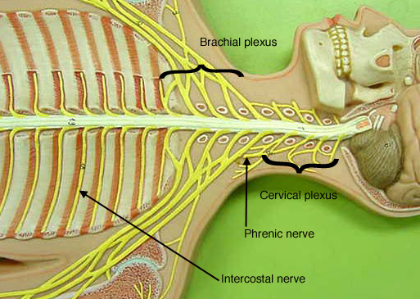
Intercostal nerves run from thoracic levels of the spinal cord to the intercostal muscles, so if the spinal cord is severed below C-5 these muscles become un-innervated. The intercostal muscles are used to provide extra-inspiratory effort or for coughing when passive recoil of the lung does not provide enough expiratory force. When the external intercostal muscles contract, they raise and pivot the ribs, thereby lifting and expanding the outer walls of the thoracic cavity causing the volume of the thoracic cavity to be enlarged.
As the thoracic cavity enlarges, it pulls the parietal pleura with it. This enlarges the fluid-filled pleural cavity and ultimately will pull the visceral pleura to expand. As a result, the lungs are pulled open and their volume is enlarged while the pressure within them is reduced. (Figure 22.16, illustrates this process.) It had to decrease according to Boyle's Law. The intrapulmonary pressure is about 3mm Hg less than that of atmospheric air. As the conduits into the lungs open, air must flow down the pressure gradient and fill the lung’s volume. This refreshes the air inside the lungs.
Expiration is usually a passive process such that it relies on the relaxation of the skeletal muscles. If the diaphragm and intercostal muscles return to their resting position, the size of the thoracic cavity decreases and the pressure in the lungs increases. Opening the passageway will allow air to exit the lungs. If you exercise heavily or have respiratory diseases such as emphysema, you may need to use the internal intercostal muscles to improve exhalation, the use of these muscles to augment normal exhalation is very metabolically expensive however.
Consider Spinal Cord Injury: What ventilatory muscles could still function if the spinal cord was severed at these locations. What would be the patient quality of life after the event?
Between C-2 and C-3:________________________________________________
Between C-5 and C-6:________________________________________________
Between T-7 and T-8:________________________________________________
Between T-12 and L-1:_______________________________________________

Exercise 5. What is it like to have Respiratory Disease?
The incidence of several pulmonary diseases is on the rise in this country and in the world. Two disease states that have drawn the most attention are emphysema and asthma. Emphysema is a disease caused by smoking and the inhalation of particulate matter. It is totally preventable (don’t smoke, or if you do quit, the trouble is that nicotine is of course extremely addictive and it takes about three weeks to break the behavioral habit).
Emphysema literally destroys the walls of the alveoli, and the elastic tissue in the lungs, both of which are important for passive exhalation. The disruption of the alveoli interferes with the lung/blood barrier by reducing the overall surface area in an alveolar sac. With less surface area there is less area for gas exchange between the air in the lung and the blood in the capillary bed. This compromises overall gas transfer to and from the blood. However, the total lung capacity and vital capacity can surprisingly be larger than average in individuals with emphysema (see below).
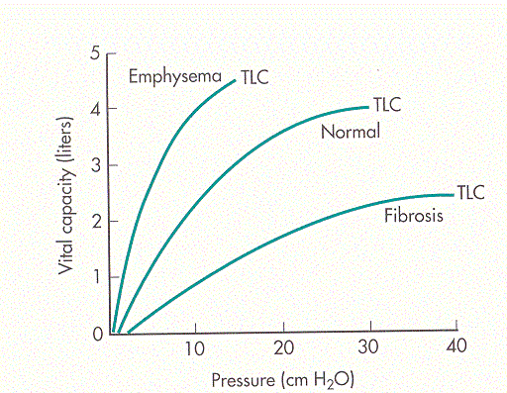
Asthma is an obstructive lung disease where the flow of gas into and out of the lungs is compromised by a narrow airway. Some irritants cause the smooth muscles in the respiratory tree to bronchoconstrict and reduce the diameter of the airways (you have all taken a whiff of ammonium). Airways can also become narrowed if they become inflamed with an infection, and this can cause tissues lining the lumen to swell (obstructing airflow). Like with the cardiovascular system, changes in resistance within a tubular conduit can greatly alter the flow of gases through the respiratory system. In this case the radius of the gas conducting tubes is substantially decreased.
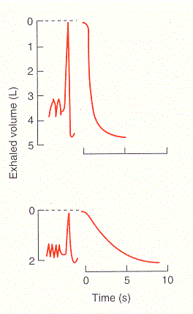
Typically a person can forcibly exhale about 75-85% percent of their total lung volume (i.e., vital capacity) in 1 second (FEV₁ – this is the Forced Expiratory Volume in 1 sec). FEV₁ will be discussed in greater detail in Exercise 7 of this laboratory exercise as part of the spirometry experiments. Which of the two recordings on the right do you think looks like an obstruction (narrowed airways) is creating increased resistance for airflow out of the lung during a forced maximal expiratory effort? Think about exhaling less air (volume liters) per unit time (seconds).
To experience what it is like to have asthma, a simple exercise will suffice. Select a volunteer from each group. You will need a clean drinking straw and a cocktail straw. Cut a drinking straw to the same length as a cocktail straw. Then measure the diameter (approximately) of each straw (in mm) and divide by 2 for the radius. How do you think radius of the straw or the radius of the airways of your lung affects potential for effective ventilation? What happens in this regard during asthma when airway smooth muscles bronchoconstrict and the airway diameter (radius) is reduced? Do try to remember that flow (air or blood) through a vessel or airway is proportional to the radius⁴! Q α r⁴. Consider child with exercise induced asthma and 2 Bronchi with a 1.2 mm diameter before and then 5 or 10 minutes after the use of their inhaled Albuterol. Why does breathing become far less labored (easier) post bronchodilation?
 | Bronchi Radius | Proportional  Air Flow (Q) | Change in Airflow  (Potential O₂ delivery to alveoli)
Asthma | 1.2 | 2.07 | PreAlbuterol
Dilate 10% (+0.12mm) | 1.32 | 3.04 | X50%- 5 minutes later
Dilate 50% (+0.6mm) | 1.8 | 10.50 | X500%- 10 minutes later

Now have the volunteer breathe normally through the drinking straw. To do this you must purse your lips around the straw to make a tight seal. As the volunteer, you must inhale and exhale through the straw. Do not cheat and breathe through your nose. Continue to breathe through the straw for about 30 seconds. Have one member of the group monitor the person's respiratory rate. At the end of 30 seconds ask the individual to describe breathing through the straw. Also note their respiratory rate. Now have the same volunteer breath through the cocktail straw. Again as the volunteer, you must inhale and exhale through the straw. Do not cheat and breathe through your nose. Try and breathe through the straw for 30 seconds. Again have a member of the group monitor the respiratory rate. Were you able to breathe through the cocktail straw well? Compare your results with that for the drinking straw. Then think about climbing stairs. With physical exertion, breathing through the straw should be almost impossible.

Exercise 6. Clinical Measurements of Ventilation: What are the Normal Values?

The spirometer records such variables as rate and depth of breathing, speed of expiration and rate of oxygen consumption. A person's size, sex, age and physical condition produce variations in respiratory volumes. Normal values used here are those of a young male (18-24 years old) in part because these values are close to whole, round numbers (and are considerably easier to remember). For a woman or smaller male, scale the numbers down to approximate the values observed. For example, normal quiet breathing in an adult male moves about 500 ml of air into or out of the lungs with each breath – this is the tidal volume (TV). Young females typically have an even smaller tidal volume. (Look at the size of a 500 ml (0.5 Liter) beaker to get a feeling for the size of a normal TV for young men.

Minute respiratory volume. or MRV, is the tidal volume multiplied by the frequency of breathing that was observed for one minute. So minute ventilation is the amount of gas moved through the respiratory system in a minute. As you will see when you measure FEV₁ a person can usually forcibly inhale or exhale much more air than is exchanged in normal quiet breathing. The terms given to the measurable respiratory volumes are defined below.
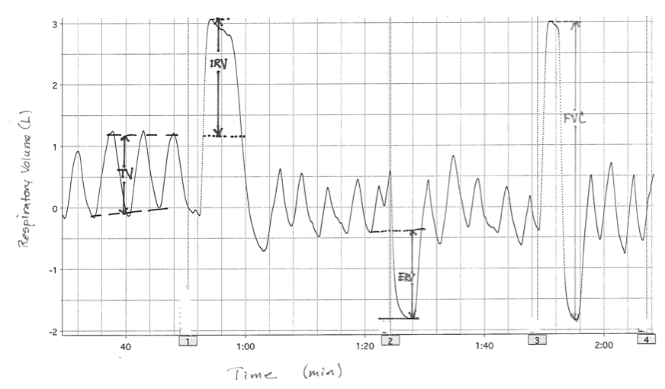
- Tidal Volume (TV) is the amount of air inhaled, or exhaled with each breath under resting conditions. (Recall that it is about 0.5 L for the adult male, it will be less for most adult females just because of body size differences.) Breathing rate is typically about 12 breaths/minute.
- Minute Respiratory Volume (MRV) is the tidal volume multiplied by the number of breaths per minute. In an adult male this is normally about 6 liters per minute, and will again be smaller for most women.
Why does MRV increase during exercise?
Why might MRV decrease when you are sleeping?
- Inspiratory reserve volume (IRV) is the amount of air that can be forcefully inhaled after a normal tidal volume inhalation. It is about 3 L for the adult male. (The above trace has a small IRV. Think about the size of a 3 liter bottle of soda.)
- Expiratory reserve volume (ERV) is the amount of air that can be forcefully exhaled after a normal tidal volume exhalation. It is about 1.2 L for the adult male. (In the above trace the ERV is slightly enlarged.)
- Vital Capacity (VC): is the sum of the TV, IRV and ERV or 0.5L+ 3L + 1.2L =4.8 L (about 5 L) for normal values for the adult male. You can calculate any one of TV, IRV, ERV, VC if you know the other three
- Forced Expiratory Volume_{1 second} (FEV₁) represents the amount of air, in liters, that can be pushed out of the lung in one second with a maximal effort. It is typically expressed as a percent (%) of VC to account for differences in height (%FEV₁). During A asthma the airway resistance is increased due to reduced diameter of bronchioles and the %FEV₁ is typically associated with a value of 0.8 or less. When you exercise, smooth muscle dilates and airway resistance increases such that %FEV₁ approaches or may even surpass 1.0.
- Residual Volume is the amount of air that is left in the lungs after a maximal exhalation. We do not fully empty our lungs with each breath. Instead, think about your lungs as air sponges. Even when you wring out a sponge it still has a damp feel to it due to the residual moisture in the sponge. The same holds true for your lungs such that after exhalation there are still air spaces that have air in them. The volume of this air space is about 1000 ml in the adult male.
- Total lung capacity is the sum of Vital Capacity plus Residual Volume, in an adult male this is about 6 liter.
Review Figure 22.17. Take your finger and trace the pattern given in the graph. As you inhale your finger should move upward on the page and as you exhale your finger should move down the page. Quiet breathing should produce that nice wave. Then pause after a normal exhalation and then as you exhale fully your finger should make a downward deflection and then return to normal breathing. Can you imagine how the movement of your finger will imitate the movements of a pen on a spirometer?
The measurement of respiratory volumes and capacities is important in assessing the severity of a respiratory disease and monitoring improvement or deterioration in a patient's pulmonary functioning. They help the clinician distinguish between obstructive and restrictive pulmonary diseases or determine overall changes in respiratory function. In obstructive diseases (e.g., chronic bronchitis and asthma) airway resistance is increased. In restrictive diseases (e.g., polio and tuberculosis) total lung capacity declines.

Exercise 7. Using Spirometry to Measure Lung Volumes in a Class Demonstration.
Your Instructor will help small groups perform spirometry on their group volunteer.

How Does This System Work? The computer measures how air flow through a metal screen in a respiratory mouthpiece changes electric current and voltage. The device also measures pressure differences on either side of the screen. The computer then runs these voltage and pressure differences through a software system that calculates two items on the computer screen: Flow (liters of air/second) and Volume (changes in liters present at any given time). This is a very different way of doing spirometry than when a bell spirometer (cylinder volume) was used. The theory behind the two practices are exactly the same. Examples are provided at the end of this lab to help you make the spirometry measurements described in this exercise.

- Select a volunteer who does not appear to be sick (no current or recent colds, coughs, etc). Obtain a clean mouthpiece from the beaker containing alcohol. Rinse the mouthpiece in water and dry with a paper towel. Obtain a new blue filter and some nose plugs and return to your seat. Attach the blue filter to the clear hose and then attach the mouthpiece to the blue filter. Your lab instructor will set up the spirometer and collect its data. Spirometry data will be collected using a computer program that converts airflow velocity across a wire screen into electric voltages that the computer converts into respiratory volumes. The computer software program used will be similar to that used in the ECG lab last week.
- As the volunteer you need to breathe normally through the mouthpiece with the nose plug attached. You will automatically modify your respiratory rate and pattern if you watch your breathing on the spirometer screen, so don’t watch. Instead turn your head away. To minimize this effect, close your eyes during this segment of the lab and listen to the instructions given by your lab instructor. Try and breathe normally, not too deep and not too fast. You should maintain a good seal around the mouthpiece and also plug your nose with the nose plugs, since you need to breathe totally through your mouth (air escape will interfere with measurements).
- The instructor will start the recording and your group will use the recording to make a number of calculations. The instructor will start the recording and have the volunteer breath quietly for 60 seconds (so you can measure breathing rate, tidal volume, and MRV). The volunteer will then be asked to take the largest inspiration possible (this will represent IRV), and they will then exhale and quickly and completely as possible. This will permit the measurement of VC and FEV₁ (remember to express FEV₁ as a percent of VC, this is called %FEV₁), after breathing returns to normal have the volunteer exhale maximally (completely) so ERV can be measured. Your instructor will then show you how to calculate these values on the board and provide a paper copy of this spirometry record.
- The residual volume (RV) cannot be determined by spirometric recordings. Use the following equation to determine the RV: RV = predicted VC X 0.25.
- If you are asthmatic and carrying your rescue inhaler you are welcome to try this exercise before and after the use of your inhaler. Prove the efficacy of this inhaler by repeating this FEV1 measurement 15 minutes after using your inhaler (albuterol for acute action/relief), the FEV1 should improve (effects of bronchodilation and stimulation of beta-2 adrenergic receptors).
Use the Spirometry Recordings from lab to calculate these parameters
 | Sex | Height (cm= inches X 2.54) | Estimated VC (L) | TV (L) | Breathing Rate (breaths/minute) | MRV (L/minute) | IRV (L) | ERV (L) | Vital Capacity (TV+IRV+ERV) | FVC  (peak of IRV to bottom of ERV) | FEV₁ | % FEV₁ (FEV₁ / FVC) X 100 | RV (VC X 0.25)
Sample  Below | Female | 165 | 3.386 | 0.9 | 19.5 | 13.7 | 2.0 | 1.4 | 4.3 | 4.4 | 3.6 | 82% | 1.1
Subject
Subject
Subject
Examine the sample Spirometry Record for practice (answers in table above), and two sample spirometry recordings to see how the calculations are made (assume this was from a 5’5” female 20 years of age).
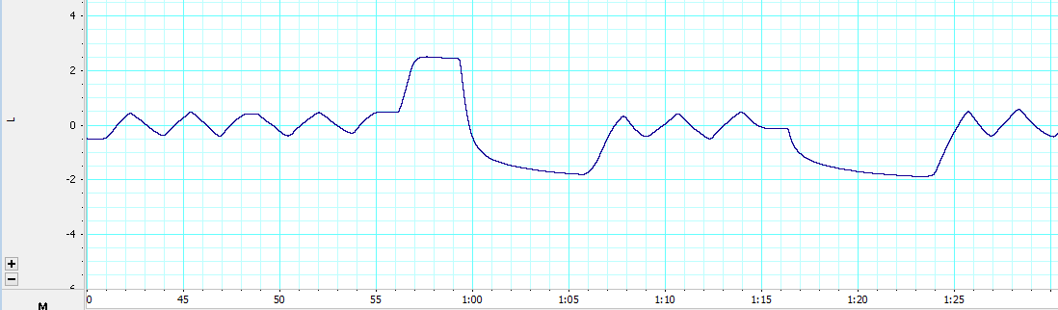
An example of a spirometry recording with mathematical calculations is provided below.
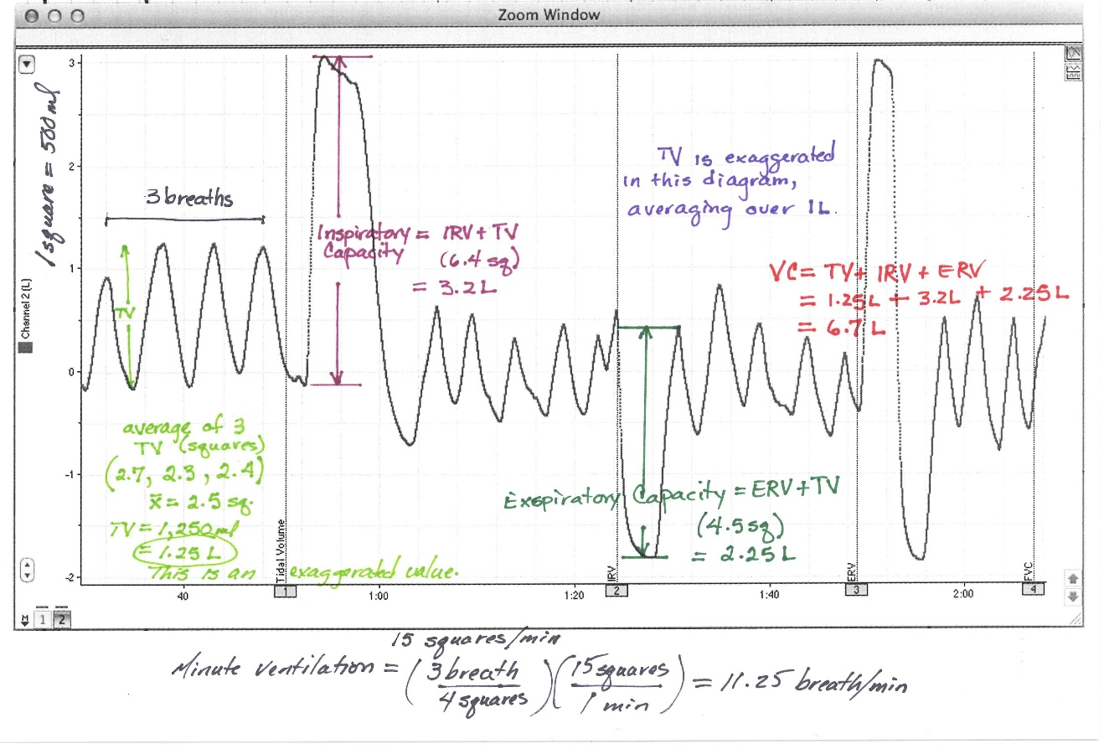

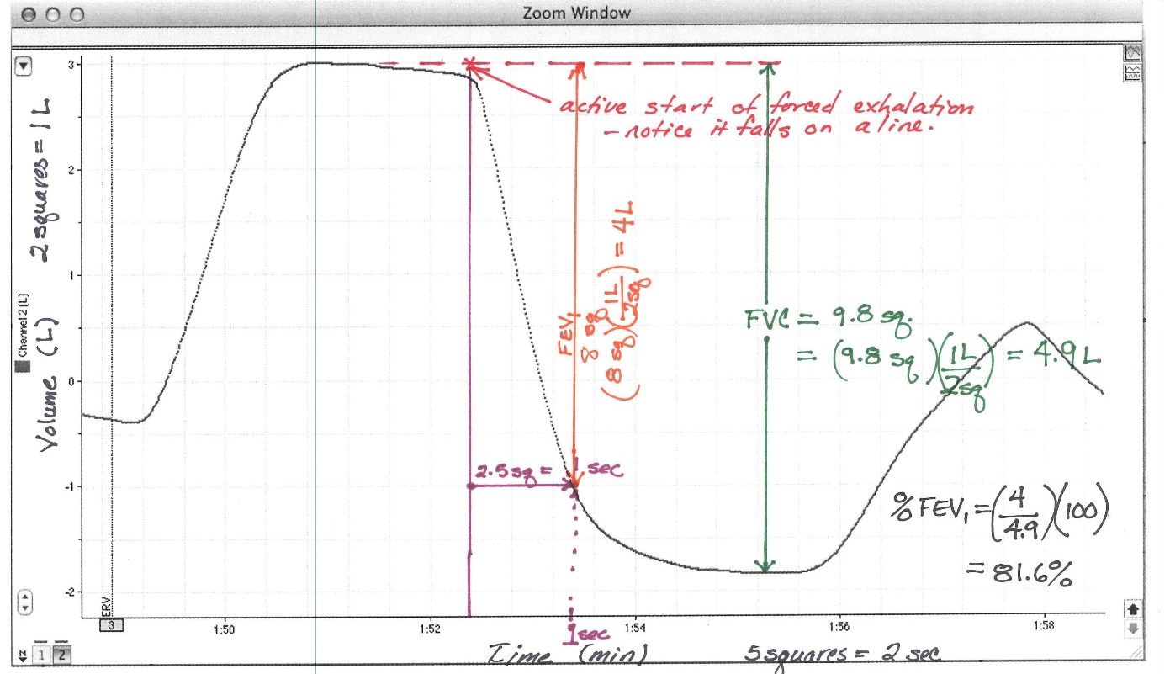

Exercise 8. Predicting Vital Capacity in a Healthy Individual: Why are predictions clinically relevant?

Predictions of vital capacity (VC) are important because they let clinicians estimate normal respiratory function and they serve as benchmarks to compare to observed values. Normal age and sex adjusted VC values are determined using tables based on many observed measurements from many people (see charts in the appendix below). For two healthy individuals of the same height, a male will typically have a higher VC than a female. As they grow s older most people have a slow reduction in their vital capacity even while remaining “healthy” for their age. If a healthy person has a VC that is far higher than expected for their sex and age, one may speculate that the person is an athlete because the value is suggestive that the person is able to deliver more O₂ to their blood and muscle.

Vital Capacity is important for predicting the severity of respiratory or even heart disease. For instance, during heart failure the left ventricle can become greatly enlarged, leaving less thoracic space (volume) for the lung ventilation. Age- and sex-adjusted VC values are compared to the actual measured values at first clinical presentation of heart disease to help predict the length of time the subject can expect to live. In the example figure below, patients with a VC close to the predicted value for healthy persons at their first visit for congestive heart failure could expect to have only 20% mortality in the next 10 years. This was indicative of a heart that was enlarged slightly and lung capacity was slightly compromised. In contrast, if the patient had a vital capacity in the bottom third of the predictive value (heart was greatly enlarged, therefore very little space left for the lungs and VC), then a clinician might predict that their chance of survival for the next decade would only be about 45% (55% chance of death). As a health provider you might need to determine the difference between true and predicted volumes, or explain why the difference is predictive of disease severity for a patient and why this predicts their lifespan.
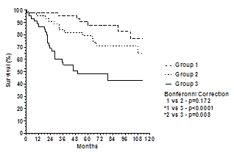
Figure from: TP Olson, BD Johnson, DL Denzer, WL Sinnett, T Wilson. Prognostic value of resting pulmonary function in heart failure. Clin Med Insights: Circ Resp Pulm Med. 2013; 7:35-43.

Use the tables for Vital Capacity (see below) to find your predicted vital capacity and to compare vital capacity for two individuals (one female and one male) who are both 175 cm tall (5’ 7.5”) and weigh about 170 pounds, and for other individuals as noted. Remember: 12 inches= 1 foot; 1 inch = 2.54 cm; 2.21 pounds = 1 kilometer

1) What is your predicted Vital Capacity?___________________

2) From the table, the predicted VC for the female is______. The predicted VC for the male is_______________.
Assume 20 years of age and healthy.

3) Now what if the same two persons were 80 years of age and still healthy
The predicted VC for the female is______. The predicted VC for the male is __________.

4) Now assume that the female is your 70 year old grandmother suffering from osteoporosis with associated kyphosis (curvature of the spine) and her measured F VC is 2.5 L. Consider the need for a large volume to compress in order to a large generate pressure gradient and a productive cough. Why is this low VC associated with a very poor ability to productive cough and greater mortality from things like pneumonia?

5) Now assume that the male is your 70 year old grandfather, getting ready for the senior Olympics (In Minneapolis this summer). His measured VC (not the predicted VC) is 4.5L. What would it mean in terms of ability your grandfather to run in 10k race? Why would this VC value be helpful in this regard?

