Biology 212: Anatomy and Physiology

Lab #9: ANATOMY OF THE DIGESTIVE SYSTEM

==================================================================================

References: Saladin, KS: Anatomy and Physiology, The Unity of Form and Function 7th (2015)

Be sure you have read and understand Chapter 25 before beginning this lab.

With COVID we are not allowed to have open lab or in-house lab activities. When the lab manual says to look at a slide, you will need to find an image online. The best I can do is put this up and suggest that when you see microscope items (histology) you simply try a google search. For example, you will need to type in the word “small intestine-villus-human” and click “images”, this should get you to quite a few images of what this looks like. Some of the content of this lab should be a review from what you learned in Bio 211, this will also be good content for a Bio 212 lab exam. There is an assignment at the end, copy past this into a separate file and submit your answers (Microsoft word, or pdf, or what ever you like) to my D2L Dropbox, but do not send the entire lab packet….just the answers to the questions at the end (this way the files will not fill too much space in D2L). If you answer things correctly and do the work, you will get the full credit for this lab, please commit to being complete however, there is not going back to revise your work on these questions.

1) INTRODUCTION:

The digestive system provides the body with the nutrients, water, electrolytes, and other substances essential for health. They enter as large masses of material which must be broken down to small molecules that can be absorbed into the blood, with residual material passing through for elimination. Organs of the digestive system are thus responsible for:
ingestion of food and liquids into the body
propulsion of this material along the digestive tract
digestion to break food down to form smaller molecules
secretion to add things to this material being ingested and digested
absorption of molecules from the digestive tract into the blood
elimination of undigested material as feces

To make things more difficult, the food and liquids we ingest contain bacteria, viruses, toxins, and many other things that are harmful to the body. Thus, your digestive tract must protect you from these at the same time it is carrying on its other functions. To do this, it essentially treats the material inside your digestive tract as if it were “outside” the body, so anything passing through its wall must pass through a number of protective structures.

The digestive system consists of a hollow tube extending from the mouth to the anus, into which various glands empty their secretions (see Figure 25.1 in Saladin). The “tube” through which food (or what used to be food) passes is called the alimentary canal, or sometimes the gut. This material must first be broken down physically by chewing, and then broken down chemically by acids, enzymes, and other materials secreted into it. These processes are called physical digestion and chemical digestion and result in molecules which are small enough to be absorbed through the wall of the alimentary canal into the blood in adjacent capillaries, by which they are then distributed throughout the body. As this occurs, smooth muscle in the walls of the various organs is propelling the material through the alimentary canal at specific rates to maximize both digestion and absorption. The residue that remains is a mixture of undigestible food, cells which died and were sloughed off from the linings of the intestines, and some waste materials that the body needs to get rid of. These form the feces that are eliminated through the anus.

The organs that produce and/or store materials to be added to the alimentary canal are called the accessory organs of digestion. These include, among many other things:

Mucous to help things pass more easily through the alimentary canal
Digestive enzymes to breakdown proteins, carbohydrates, lipids, and nucleic acids

Bile for the emulsification of fats
Antibodies to help protect the body against organisms and debris which are ingested
The organs of the alimentary canal include the mouth, pharynx, esophagus, stomach, small intestine, large intestine, and anus. The accessory organs include the salivary glands, liver, gall bladder, and pancreas.

Before we can digest food and extract its nutrients we have to “decide” to eat food. Ingestion (the process of eating) begins with the sense of smell (olfaction) and taste (gustation). If food does not taste or smell “good” we generally do not want to eat it (odd cultural exceptions might include Norwegian Lutafisk, Tripe, or Limburger cheese). Food has 4-5 different unique tastes that include: sweetness (does food have sugars?), sourness (is food acidic and dangerous?), saltiness (does food contain NaCl?), savoriness or umani (think soy-sauce- does food contain protein?), and bitterness (does food contain poison?). The receptors for “bitterness” are on the far back of your tongue, if may poisons have an alkaline or bitter taste, why might this be protective for letting you evaluate food just before you swallow it? Olfaction comes from receptor cells that line the mucus membrane of the nasal cavity. The sensory cells of olfaction and gustation all require a series of micronutrients such as magnesium, manganese, lithium etc, if we have poor nutrition these micronutrients may not be present in our diet and deficient for food to taste or smell “appealing”. For an anorexic person who is not eating enough and deficient in these micronutrients, why then might food not taste or smell “appealing”. If food does not smell or taste good, we tend not to eat, so why might nutritional deficiency leading a continued worsening of these same nutritional deficiencies?

Learning Objectives: Upon completion of this exercise students will be able to
- Describe the things that make us want to ingest food
- Describe the gross anatomy of human digestive system
- Describe the gross anatomy of the human liver
- Describe the gross anatomy of the human pancreas
- Describe the histology of the human intestine, liver and pancreas
- Describe the interface between blood and bile in the hepatic lobule
- Describe the how starch digestion begins with amylase in the mouth

2) GROSS ANATOMY OF THE DIGESTIVE SYSTEM:

Let’s start out by examining the digestive system in the torso model, using figures in your Saladin text to help you identify structures. Identify the oral cavity, including the lips, tongue and teeth. This is bounded superiorly by the hard palate and the soft palate, anteriorly by the lips, and laterally by the cheeks. Identify the boundary between the oral cavity and the oropharynx, noting the uvula extending from the soft palate. The sublingual salivary gland and the submandibular salivary gland are shown on the side that is cut away and is opened; the parotid salivary gland is shown just under the skin on the other side, anterior and inferior to the ear. Be sure you understand how and where the saliva produced by each of these is delivered into the oral cavity.

The laryngopharynx and esophagus in the neck are not shown on the torso models, but you should understand their locations.

Questions for discussion:

The laryngopharynx is an inferior continuation of which other part of the pharynx?
Where does it lie relative to the larynx?

The esophagus runs posterior to what other tubular organ?

The esophagus is primarily involved with only two of the functions listed on page 1. Which are these? (The first one is easy. For the second one, think of mucous)

Identify where the esophagus enters the thoracic cavity of the torso model. It lies posterior to the heart, in a region of the body called the posterior mediastinum. Notice that it curves slightly to the left as is nears the diaphragm.

Identify where the esophagus passes through the diaphragm into the abdominal cavity of the model, quickly entering the stomach. This organ lies to the left of the midline and is posterior to the liver, inferior to the diaphragm, superior to the transverse colon, and to the right of the spleen. Identify its greater curvature, lesser curvature, cardiac region, fundus, body, and pyloric region. Open the stomach and notice how its mucosa is thrown into ridges called rugae.

Identify the location of the pyloric sphincter valve, leading from the stomach into the small intestine on the model. Although food enters the stomach quickly from the esophagus, the partially digested material called chyme is released from the stomach into the intestine in small amounts over many hours after a meal. Notice how the first part of the small intestine, the duodenum (“first 12 fingers”), remains close to the posterior body wall as it curves inferiorly and then back to the left in the shape of a “C” - it is the only part of the small intestine that is retroperitoneal. The duodenum is responsible for neutralizing stomach acids so that intestinal enzymes can be active in more distal sections of the intestine.

Questions for discussion:

Define, in your own words (don’t read from the book!) what “retroperitoneal” means.

Define, in your own words (don’t read from the book!) what “intraperitoneal” means.

The second and third parts of the small intestine are intraperitoneal - they are attached to the posterior body wall by a thin mesentery (not shown on the model) and have relatively free movement within the abdominal cavity. These are the jejunum (lots of enzymatic digestion of nutrients and some absorption of nutrients) and the ilium (some enzymatic digestion and lots of absorption of nutrients), which together are six to seven meters in length but coil to fit compactly within the abdomen. On the model, these are shown as a single mass of plastic, but you should realize that in life it is a single coiled tube. The division into jejunum and ilium is based primarily on histologic criteria, so they will not look any different on the model.

In the lower right part of the abdomen of the model, identify where the ilium meets the large intestine, or colon, at the ileocecal junction. The color is responsible for reabsorbing the materials (i.e. water and bile salts) that enters the gut in the small intestine to facilitate digestion and nutrient absorption. If too much water is reabsorbed then constipation will result, if not enough water is reabsorbed you experience diarrhea and potential dehydration.

This most proximal part of the large intestine is a pouch called the cecum, and the appendix can be seen extending from it. The next part of the large intestine ascends along the right side of the abdomen and is called, appropriately, the ascending colon. Just inferior to the liver, it curves to the left as the transverse colon, then near the stomach and spleen it curves inferiorly to descend along the left side of the abdomen as the descending colon. As it nears the pelvis, the large intestine curves twice to form the S-shaped sigmoid colon, then straightens out as the rectum (poorly shown on the models. The ascending and descending colons are retroperitoneal, while the cecum, transverse colon, and sigmoid colon are intraperitoneal. Notice how the external surface of the large intestine is thrown into transverse folds, called haustra.

Questions for discussion:
What is the bend (flexure) called where the ascending colon forms the transverse colon?

Where is this in relationship to other organs in the abdomen?

What is the bend (flexure) called where the transverse colon forms the descending colon?

Where is this in relationship to other organs in the abdomen?

Observe that many blood vessels extend out to the large intestine. Although not shown in the plastic mass on the model, the small intestine also has an extensive supply of blood vessels. Digestive motility requires ATP much of which is supplied by the mitochondria, hence the need for oxygen. The arteries (red on the model) represent branches of the superior mesenteric and inferior mesenteric arteries, while the veins (blue- after oxygen utilization) represent branches of the superior mesenteric and inferior mesenteric veins.

The liver is perfused by two blood vessels, oxygenated blood is delivered by the hepatic artery which immediately branches off the celiac artery located on the aorta immediately distal to the diaphragm. The hepatic portal vein delivers blood from the intestines that has been depleted of much of its oxygen (slightly bluish in color). Blood leaving the intestines has potentially absorbed nutrients that need to be delivered to the body, but this blood can also pick up pathogenic chemicals or bacteria from the intestine. These pathogens need to be removed in the liver lobules before the blood is delivered into the vena cava.

The hepatic lobules of the liver permit these oxygenated and deoxygenated blood supplies to merge, as this blood passes along sinusoids it is hopefully cleaned of toxins, wastes, harmful bacteria prior to reaching the central vein that lies at the center of each lobule. The dark red color of the liver reminds us of the metabolic work (mitochondria, oxygen utilization, and ATP production) required by the liver to complete this task, hence the need for oxygenated blood and the heaptic artery (portal blood is slightly hypoxic). The hypoxic but cleaned blood in the central veins are ultimately delivered into the hepatic vein that delivers the blood into the vena cava which returns the systemic blood it to the heart and lungs for oxygenation.

Questions for discussion:

Blood enters the superior mesenteric and inferior mesenteric arteries from which larger vessel?

The superior mesenteric artery supplies which parts of the intestines?

The inferior mesenteric artery supplies which parts of the intestines?

The superior mesenteric vein drains blood from which parts of the intestines?

The inferior mesenteric vein drains blood from which parts of the intestines?

Both the superior mesenteric vein and the inferior mesenteric vein (together with the splenic vein) deliver blood to which larger vein? To what organ does this vein deliver the blood?

Why might an obstructed hepatic artery (i.e atherosclerotic plaque) lead to liver disease?

Reassemble the model so all parts of the digestive system are in their proper locations. Observe the large size and the location of the liver. It is the most superior organ in the abdominal cavity, covering most of the inferior surface of the diaphragm. It is the largest internal organ - second only to the skin among all organs of the body. Most of its mass lies to the right. It has a sharp inferior border, but other surfaces and borders are more rounded. The liver is easily taken for granted. It does its’ job quietly and efficiently for almost our whole lives… then, when it does start to fail us, it is often too late. For these reasons it is sometimes called a "non-complainer". Many blood and urine tests indirectly give us a glimpse into liver function and health.

Major functions of the liver: Estimates regarding the organ's total number of functions vary, but textbooks generally cite it being around 500 different functions some of which are described below.

1 - vascular functions - the liver filters and cleans blood – it monitors and modifies the chemicals from our food, but it is also the only organ that removes toxic chemicals from blood and either detoxifies them (by changing them chemically into something less toxic) or excretes them (via bile). The liver produces almost all types of plasma proteins, and also monitors their condition, removing and recycling the proteins as they age. The liver also recycles components removed from red blood cells and platelets into amino acids, while the heme from degraded hemoglobin molecules becomes a component in bile.

2 - metabolism of fats, carbohydrates and proteins. Once digestion and absorption of energy-yielding nutrients in food is over, the liver modifies these chemicals to make sure our cells have an appropriate mixture of glucose, amino acids, and fatty acids available to them. The liver is not "controlling" this balance of nutrients because it is simply responding to signals from our control systems. Liver is thus a major target organ in metabolism, as we will see in coming weeks.

- liver is the only organ that can make glucose from non-carbohydrate sources

- liver is "lipid central" as it makes lipoproteins, and recycles them

- liver is the only organ that can make one amino acid from another (but not all 20)

3 - endocrine and storage functions. The liver produces several hormones: IGF-1, angiotensinogen, thrombopoietin (an analog of EPO for platelet production), and hepcidin (a hormone that regulates iron absorption by the intestines). The liver also metabolizes and excretes steroid hormones.
- liver cells store glucose (as glycogen) and fatty acids (as triglycerides)
- liver cells store iron, copper, and several vitamins (A, D, K, B₁₂)

4 - bile -> emulsification of lipids in the small intestine – The “heme” in hemoglobin that hold Fe++ and oxygen is degreaded into bilirubin and excreted in bile. This give the feces a brown color and is essential for efficient digestion of lipids in our food. And efficient digestion is crucial for the efficient absorption of dietary lipids (often incorrectly referred to as "dietary fats"), which include several fat-soluble vitamins, as well as essential fatty acids (omega-3 and omega-6 fatty acids).

5 - bile -> an essential route for excretion of non-polar molecules. A second essential role for bile is as an excretory route for non-polar chemicals. The liver can alter many toxic molecules to allow them to safely travel via blood to the kidneys, but it cannot do this for all molecules. Bile is how we excrete bilirubin, steroid metabolites, and many (non-polar) drug metabolites and other foreign chemicals.

Remove the liver from the model, and on its inferior surface identify the gall bladder and the entry of three tubes: the hepatic artery (red), the hepatic portal vein (blue), and the common bile duct (an ugly green). Notice that the cystic duct, which branches from the common bile duct, runs to the gall bladder. The gall bladder stores bile until it is needed, then sends it down the common bile duct to the duodenum. Sometimes bile salts and other materials for precipitations that develop into painful hardened gallstones in this organ leading to inflammation and a need for surgical removal of this gland (cholecystectomy). Why are we less able to digest fatty foods after surgical removal of the gall bladder (Cholesystectomy)?

Remove the stomach from the model and identify the pancreas posterior to it. Identify the pancreatic duct and follow this to where it empties its contents into the duodenum at the same location that the common bile duct did so. The pancreatic acini are the source of many of the digestive enzymes that help the small intestine digest proteins, RNA and DNA. If these digestive enzymes become active in the pancreatic ducts, they may digest the pancreas itself resulting in acute or chronic pancreatitis which is very life threatening.
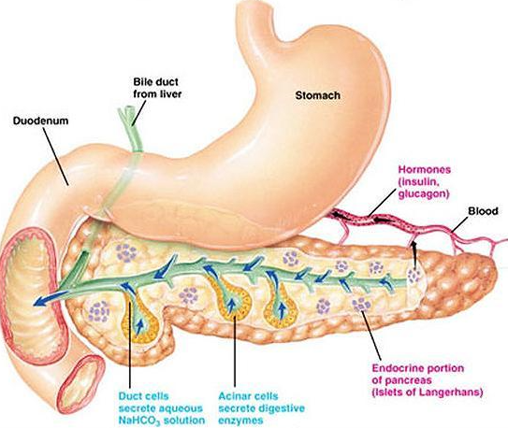

Questions for discussion:

What is the function of bile in digestion?

Blood enters the hepatic artery from which branch of the aorta?

Blood enters the hepatic portal vein from what three smaller vessels, carrying blood from capillaries in what organs?

What if the primary function of the pancreas in the function of the digestive system?

Name three specific digestive enzymes secreted by the pancreas and what specific type of molecule each of them acts on (e.g. proteins, starch, etc

3) HISTOLOGY OF THE DIGESTIVE SYSTEM:

Review from Bio 211 Exercise 1: Slide 21 in your slide set shows the salivary glands. Start off by scanning this at 40X. There are sections of three different salivary glands on this slide. The common structure of the glands, seen at higher magnification, is to have hollow tubes of secretory cells attached to a system of ducts that carry the saliva into the mouth (see Figure 25.9 in Saladin). The clusters of cells making up the walls of the tubes are called acini or sometimes alveoli. There are two kinds of acini in salivary glands: darker-staining serous acini and lighter-staining mucous acini (you may need to review Chapter 5 in your Saladin text). One of the glands on the slide has only serous acini, another has only mucous acini, and the third has mixed (both serous and mucous) acini.

Examine the gland with mixed acini. The mucous acini are lighter-colored groups of cells that produce the thicker mucus in saliva. The serous acini are darker colored clusters, some of which may be arranged in half-moons of cells capping a group of mucous cells. They produce a thinner, more watery saliva containing starch-digesting enzymes. Identify the salivary ducts that carry saliva toward the mouth. These structures have a large, open lumen (space) in the middle, surrounded by a simple cuboidal epithelial layer. These ducts are often surrounded by a moderate amount of connective tissue. Identifying characteristics for this slide are the combination of the two kinds of acini and the ducts.

Review from Bio 211 Exercise 2: Slide 9 shows the esophagus; find a slide in which it was cut in cross-section to show the entire wall. Scan it at 40X and find the central lumen. Switch to higher magnification. Surrounding the lumen is a thick layer of stratified squamous epithelium. Note that the upper cells are thin and flattened parallel to the surface (squamous), but many of them still have nuclei. This is called a non-keratinized or non-cornified type of epithelium. Immediately beneath the epithelium is a thin layer of areolar connective tissue and possibly some scattered smooth muscle cells. The epithelium plus the connective tissue makes up the mucosa of the organ.

Superficial to the mucosa of the esophagus is a thicker layer of areolar connective tissue called the submucosa. It may have some multicellular glands in it. Superficial to this, identify the thick layers of skeletal or smooth muscle making up the muscularis externa. In life there is a layer or areolar connective tissue called the adventitia on the outside of the organ, but this is often missing on the slides in our lab.

Hepatic Histology Exercise 3: Slide 23 shows the liver. Scan it at 40X to locate the structures then switch to higher magnification to examine them. Look for the thin walled central veins, each of which is surrounded by large capillaries called sinusoids arranged like the spokes of a wheel around it. The cells lining the sinusoids are the hepatocytes, arranged in “cords” which also radiate like spokes from the central vein. Each central vein with its sinusoids and cords of hepatocytes forms a hepatic lobule. Remember that the sinusoids represent a second set of capillaries (first were located in the intestine), as a result this is a portal system. Portal blood flow also exists in the anterior pituitary of the brain and kidney.

At the edge of the lobules you can identify three structures that sit close together to form a hepatic triad (sometimes called a portal area). The first of these is a bile duct, carrying bile away from the hepatocytes and leading, eventually, to the common bile duct. Bile canaliculi within the lobule carry the bile from the center towards the bile ducts located in the outer corners of each lobule (these are tough to see with your microscopes). The hepatic arteriole is a branch of the hepatic artery, and the venule is a branch of the hepatic portal vein. Both of these vessels deliver blood into the sinusoids, where it flows past the hepatocytes on its way to the central vein and, eventually, out of the liver into the inferior vena cava.
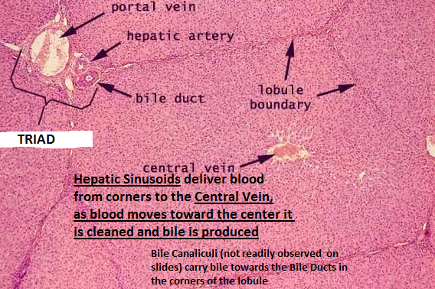

Review from Bio 211 Exercise 4: Slide 20 shows a section of the pancreas. Although a small part (about 1%) of this organ consists of endocrine cells, most of it is involved with the production and secretion of digestive enzymes, which are sent by the pancreatic duct to the duodenum. As always, start off by scanning the slide at 40X, referring to Figure 25.22 in your Saladin text. Look for clusters of lighter staining cells - these are the cells of the endocrine pancreatic islets (see image below). If your slide has none visible, look at another slide that has them - they are an excellent way to identify the gland.

The rest of the pancreas consists of darker-staining pancreatic acini. It also has a well-developed system of connective tissue partitions that break the gland up into many smaller pieces. Identify the small pancreatic ducts which usually surrounded by a moderate amount of areolar connective tissue.

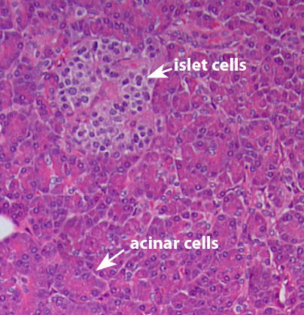 | 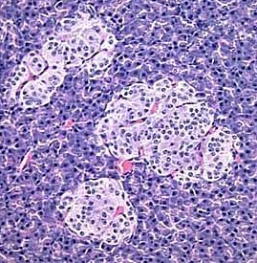

Questions for discussion:

What are the functions of saliva in the human digestive system?

What would result if your salivary glands became unable to produce any saliva?

What are the functions of the liver and gall bladder in the human digestive system?

What would result if your liver became unable to carry out these functions?

What are the functions of the pancreas in the human digestive system?

What would result if your pancreas glands became unable to carry out these functions?

Review from Bio 211 Exercise 5: The small intestine of a frog is shown on slide 5, although this is not completely typical of the structure of the human intestine. Scan this at 40X before switching to a higher magnification. Note the four main layers of the organ are present: inner mucosa, submucosa, muscularis externa and outer serosa.

The epithelium of the mucosa is simple columnar epithelium. In this cellular array look for and identify the goblet cells. These are mucus-producing cells (in essence, one-celled glands) that appear to have a goblet-shaped clear area in them. Under the epithelium lies a thin layer of areolar connective tissue called the lamina propria. These two layers make up the mucosa. The mucosa is folded into many finger-like projections called villi; notice how the lamina propria extends into them. Villi are useful features in identifying this organ, since most tubular structures in the human body do not have them.

Although they have collapsed on this slide and cannot be easily located, realize that many blood vessels and lymphatic vessels lie within the villi (see Figure 25.25 in Saladin). Molecules being absorbed from the lumen of the intestine will enter these vessels, and then eventually be carried out of the intestine and distributed throughout the body.

The submucosa is hard to distinguish from the lamina propria on some slides, which is what makes this slide of amphibian intestine different than its appearance in humans and other mammals. A thin layer of smooth muscle, called the muscularis mucosa, would lie between the lamina propria and the submucosa, very similar to that shown for the esophagus in Figure 25.2 of your Saladin text. Perhaps the best place to find it is right next to the muscle layers (muscularis externa) which are superficial to it. It often has a slightly denser texture than the lamina propria.

The muscularis externa consists of two layers of smooth muscle tissue. The inner layer is thicker and is called the circular layer due to the circular orientation of its fibers around the tube-shaped intestine. Since this is a cross-section of the organ, the cells of this layer are cut lengthwise. The outer muscle layer is much thinner. It is called the longitudinal layer. These cells run longitudinally along the intestine (actually, they form a loose spiral around it), so they are cut in cross section on this slide. This double layer of smooth muscle is another feature that should help you identify this organ.

4) ENZYMATIC DIGESTION:

After we put food in our mouths, we need to chew it, the process of chewing (mastication). We use our incisors to bite a chunk of apple, our canines to hold prey (if we used them like wolves do), incisors to sheer it into smaller chunks, and the molars I the back to grind food into very small pieces (mush). Mastication is made easier when saliva is secreted from the salivary glands, sometimes we only need to “think” about food to begin salivation and the preparation for ingestion and mastication. Saliva lubricates (hydrates) food and mixes in enzymes such as lysozyme (break up cell walls of bacteria- think why saliva from a dog sometimes helps healing in their cut when they lick it) and amylase. Salivary Amylase is an enzyme that helps break long carbohydrate chains (starch in a cracker) into smaller more easily digested pieces.

Every enzyme has an ideal pH and temperature where their activity is optimal. The mouth has a pH of about 6.5 and a temperature of 85-95 F. If we vomit the pH in the mouth approaches 2.0 until bicarbonate in the saliva neutralizes the acid. A lot of people had the Flu this spring and experience vomiting, some more robustly than others shall we say. What happens to enzyme activity in the mouth after we vomit? Why might our ability to digest starch change after we vomit and how does this reflect on our ability to digest starch in our mouth? Lets look at how does pH affect the activity of the amylase we use to digest the starch in a cracker?

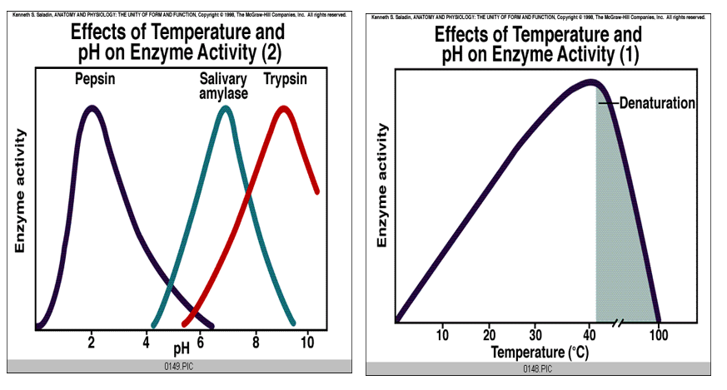

5) Colonoscopy and Colon Cancer Screening:

Colon cancer is a type of cancer that begins in the large intestine (colon). Colon cancer typically affects older adults, though it can happen at any age. Overall, the lifetime risk of developing colorectal cancer is: about 1 in 23 (4.4%) for men and 1 in 25 (4.1%) for women. In the United States, colorectal cancer is the third leading cause of cancer-related deaths in men and in women, and the second most common cause of cancer deaths when men and women are combined. Colon cancer will cause about 53,200 deaths during 2020. https://www.cancer.org/cancer/colon-rectal-cancer/about/key-statistics.html

It usually begins as small, noncancerous (benign) clumps of cells called polyps that form on the inside of the colon. Over time some of these polyps can become colon cancers. Polyps may be small and produce few, if any, symptoms. For this reason, recommend regular screening tests to help prevent colon cancer by identifying and removing polyps before they turn into cancer. Colon cancer is sometimes called colorectal cancer, which is a term that combines colon cancer and rectal cancer, which begins in the rectum (Mayoclinic.org). Because the cells lining the colon have a high rate of mitosis (cell division) and because potential carcinogens can be created as a by product of digestion and the functioning of the normal gut flora damage to the DNA of these cells can more easily occur, although genetic predisposition is also predictive of colon cancer risk. Be sure to examine the current CDC recommendations for colon cancer and ask if you, your parents or grand parents are at risk. https://www.cdc.gov/cancer/colorectal/basic_info/screening/index.htm
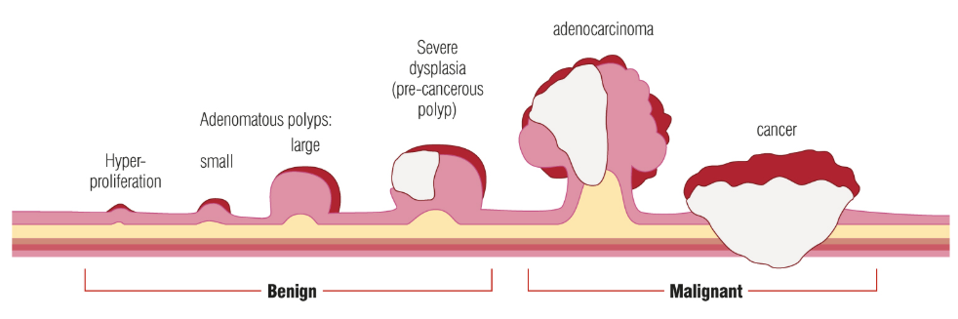 | 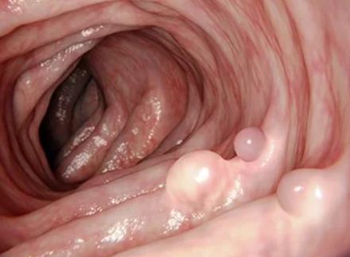
https://gutscharity.org.uk/advice-and-information/conditions/bowel-cancer/ | Polyps in Colon

NAME:_____________________(type or write in the blank)
DIGESTIVE SYSTEM LABORATORY REVIEW Questions: 10 points
CUT-PASTE this assignment into a separate Microsoft Word file and write or type the answers in that document. Submit the document to D2L when you are finished.

1) Write a minimum of 15-25 words to describe each of the following items:
a) Describe the gross anatomy of human digestive system
b) Describe the gross anatomy of the human liver
c) Describe the gross anatomy of the human pancreas
d) Describe the histology of the human intestine, liver and pancreas
e) Describe the interface between blood and bile in the hepatic lobule
f) Describe the how starch digestion begins with amylase in the mouth

2) Compare and Contrast the the following (15-25 words per item):
a) Blood flow into and out of the intesines, liver (hepatic portal flow) and stomach
b) How does the function of the pancreas and liver differ with respect to digestion, bile, and enzymes,?

3) Describe the enzymes used to digest the following (15-25 words per item):
a) Starch in the mouth and intestine
b) Triglycerides in the mouth and intestine
c) Protein in the stomach and intestine
d) Describe how ph (acid/base) is used to control where each digestive enzyme is active or inactive
relative to the mouth, stomach and intestine

4) Talk to a person by phone (to honor social distancing needs) who has had a colonoscopy (you could ask your parents or others for help finding someone). Ask about the experience and find out hteir age. Did the find polyps, and if so when are they supposed to have a follow-up screening? Write 30-40 words about what their age, risk, and what the examination showed (they need not have found polyps for this exercise).

