Reference to literature below and reference to a Left Bundle Branch Block from the literature and from a past student in AP 212 who had a “LEFT” Bundle Branch Block
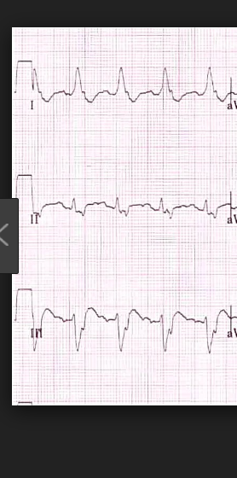 | 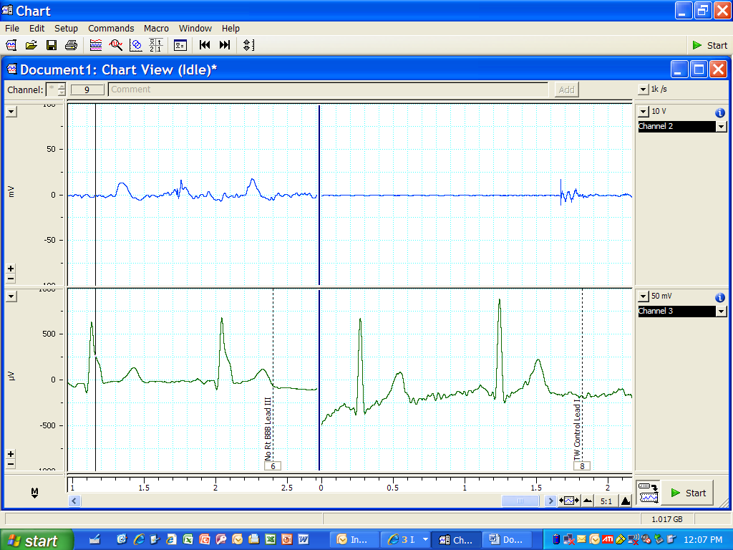

Grace C: Probably Left Bundle Branch Block, family history aortic aneurism, stroke and heart attack
Lead I: Pulse top, ECG bottom
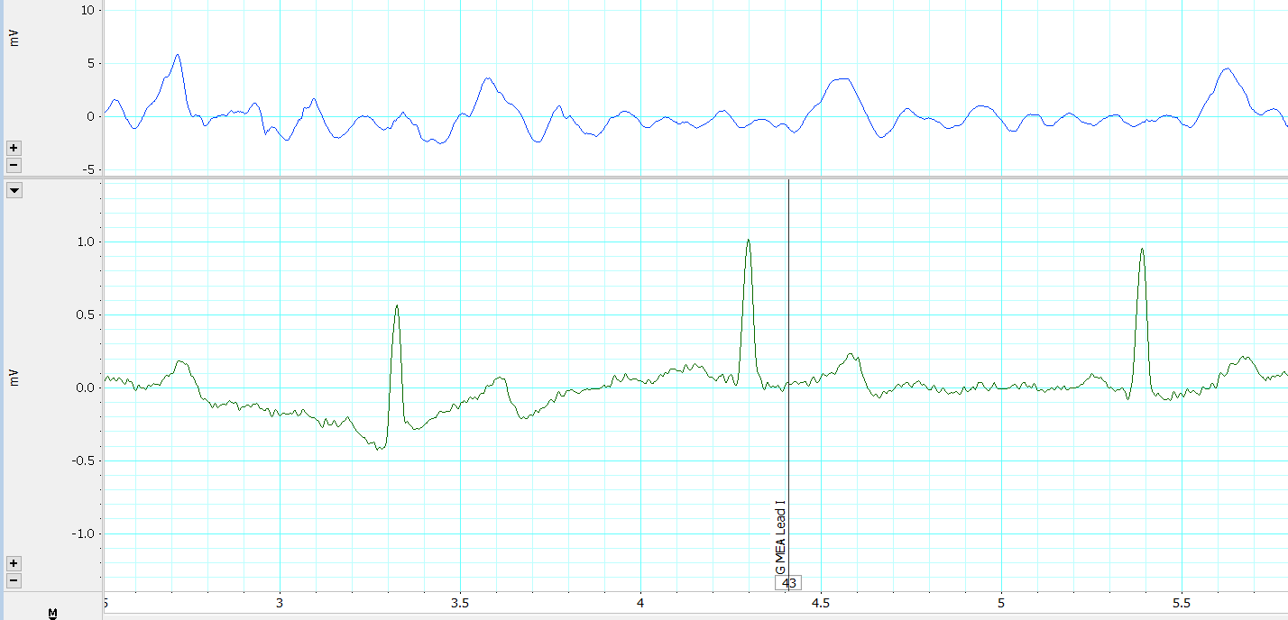
Lead II: Pulse top, ECG bottom
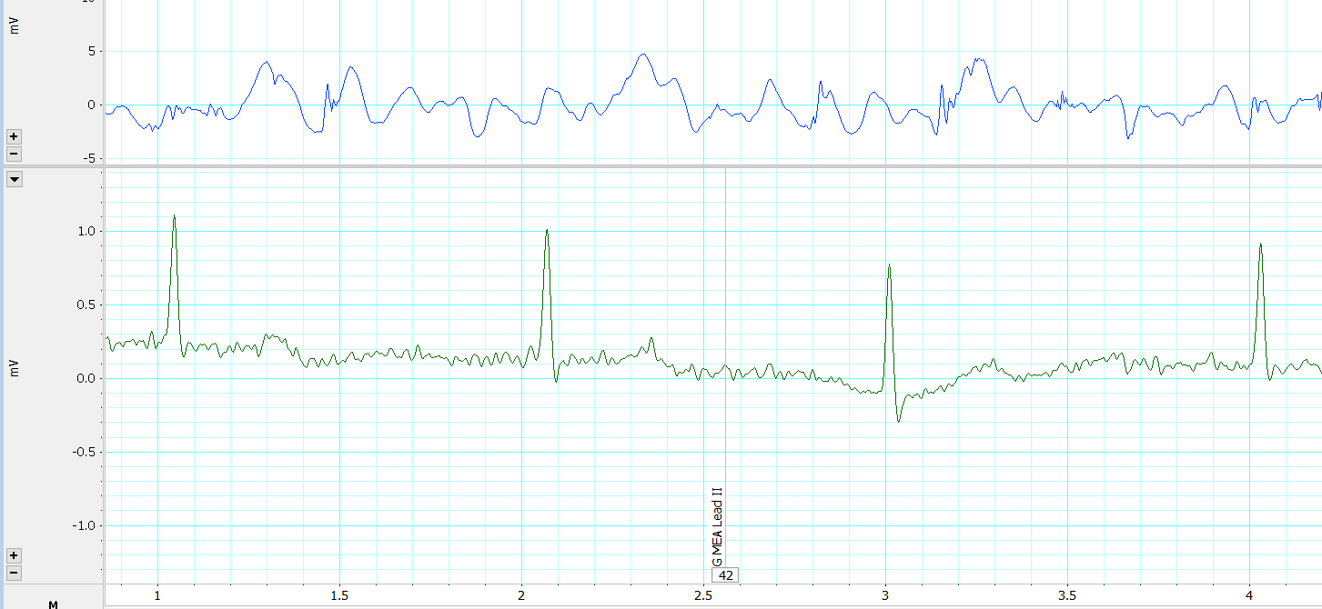
Lead III Pulse top, ECG bottom
