FORM- A Name: _____________practice quiz AA______________
Anatomy and Physiology 212: Quiz #2 ON YOUR SCANTRON, PLEASE PUT YOUR NAME AND TEST FORM LETTER ON FRONT! Multiple Choice (1 pt each): Choose the one best answer for each question, use a pencil to mark answer on scantron (double check for smears).
1) a)True b) False: HDL particles can remove cholesterol from an atherosclerotic plaque and deliver it to the liver.
2) a) True b) False: Hemoglobin binds to oxygen more tightly when the blood pH is acidic and the temperature is warmer than normal.
3) a)True b) False: During exercise, acidity in the blood increases the supply of oxygen to tissues by increasing the affinity of oxygen for hemoglobin.
4) a)True b) False: Blood perfuses the heart by running from arteries in the outer epicardium towards the inner endocardium.
5) a)True b) False If you hyperventilate your blood becomes acidic improving oxygen delivery to your brain.
6) The pacemaker potential of cells in the SA and AV nodes results primarily from the slow inflow of….
a) Calcium b) Sodium c) Potassium d) Epinephrine
7) Electrical depolarizations pass between cardiac myocytes through…..
a) Gap junctions b) Synapses c) Desmosomes d) All of above
8) The heart is sensitive to hypoxia because it uses about ________of the oxygen consumed in the body.
a) 1% b) 2% c) 10% d) 25% e) 35%
9) If the P-Q Segment of an ECG was longer than normal, you would be observing a ___________heart block.
a) First degree b) Second degree c) Third degree d) Sinus rhythm e) Ectopic foci
10) Which have the fastest rate of conduction (about 3 meters/second) in the heart?
a) Atrial myocytes b) AV Node c) Purkinje fibers d) Ventricular myocytes e) Fibroblasts and collagen
11) Which of the following events occur in the period between the end of the T-wave and the start of the next R-wave on the ECG?
a) Ventricular quiescence b) Ventricular diastole c) Ventricular rest d) Ventricular perfusion with arterial blood e) All of above
12) What cardiac cycle event would occur if the AV-valve and semilunar valves were closed and the healthy ventricle contained 130 ml of blood and the pressure was increasing?
a) End Diastolic Volume b) Isovolumetric contraction c) Ventricular diastole d) Atrial Systole

13) During the ____phase of a cardiac cycle ventricular volume is increasing with a ventricular pressure is remaining mostly unchanged at about 4 mmHg.
a) Isovolumetric relaxation b) Ejection c) Diastole d) Isovolumetric Contraction

14) What is an approximately NORMAL heart rate, cardiac output and aortic blood pressure at the level of the heart?
a) 70 beats/minute, 4.9 liters/minute, 120 mmHg/80 mmHg
b) 50 beats/minute, 2.5 liters/minute, 90 mmHg/50 mmHg
c) 100 beats/minute, 35 liters/minute, 170 mmHg/100 mmHg

15) Which cells of a HEALTHY heart have the second fastest rate of autorhythmicity (pacemaker rate)?
a) Cells of Apex b) Cells of Bundle of His c) Cells of AV Node d) Cells of SA Node

16) What structure permits adjacent cardiac cells to depolarize each other
a) Actin b) Troponin c) Gap Junctions d) Voltage-gated sodium channels

17) A ______degree heart block would occur if a P-wave came before all QRS-complexes, but some P-waves were not associated with a QRS complex.
a) First b) Second c) Third d) Ventricular fibrillation

18) What ECG wave is associated with ventricular depolarization?
a) P-wave b) R-wave c) T-wave

19) What type of abnormal Mean Electrical Axis (MEA) would you expect to see in a person who had an aortic valve (left semilunar) that failed to open completely (stenotic) during ventricular systole?
a) 0 to -90 degrees b) 0 to 90 degrees c) 90 to 180 degrees

20) The inside of the heart is covered by endothelial cells and called the…..
a) Endocardium b) Myocardium c) Epicardium d) Pericardial sac

Extra Credit: (1 point) What is the cardiac output for this heart? Show Math
Extra Credit: (1 point) Is this heart rate sustainable? WHY/WHY NOT? (5-10 words)

0.0 seconds 0.25 seconds 0.5 seconds

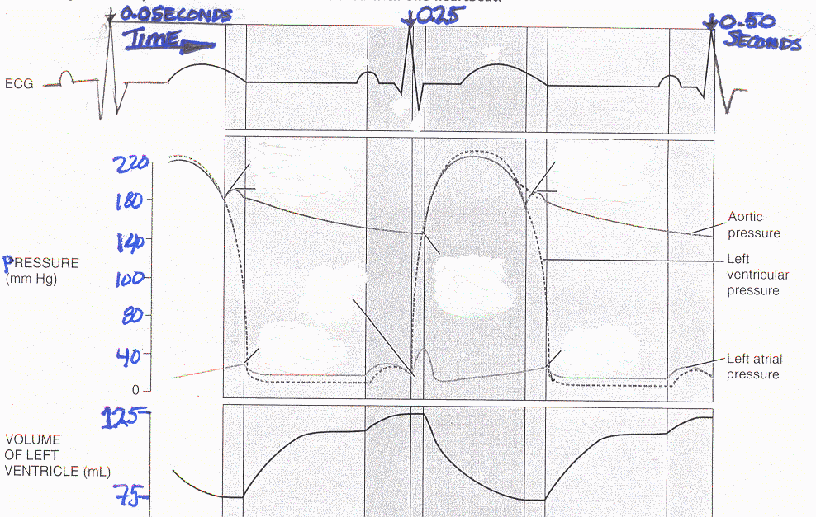
75 ml 110ml 125 ml 75 ml

