Name:_______________
Spirometry Assignment: 10 pts Complete these Four Spirometry Records
HAND IN these three pages with the answers and measurements (use ruler, show all math).
Please make a copy to study for lab/lecture exam (you can turn in the copy or the original).
2 pts: Spirometry #1: Assume person was 240 pounds and 6 foot 3 inches tall. Calculate TV, Breathing Rate, MRV, IRV, VC, ERV, FEV₁ (L) and FEV₁ (expressed as a percent of VC). Are these values normal, low or higher than average? Show math, scales, and answer (liters, breaths/min, %FEV₁) for this recording:
Liter Scale four TVs IRV FEV1 two TVs ERV

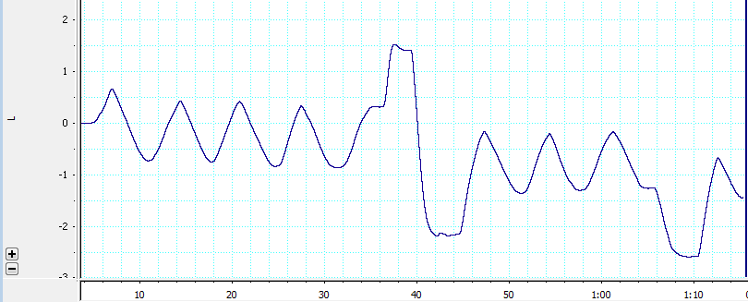
Scale: Volume-___liters= ____mm Rate: _____seconds = ___mm paper
TV: IRV:

ERV: VC:

FEV₁ (L) %FEV₁ .

Breathing Rate: MRV:

Is each value normal, low or higher than average?

Any reason to think this person has asthma? Why or Why not?

2 pts: Spirometry #2: Assume this woman was 140 pounds and 5 foot 3 inches tall. Calculate TV, Breathing Rate, MRV, IRV, VC, ERV, FEV₁ (L) and FEV₁ (expressed as a percent of VC). Are these values normal, low or higher than average? Show math, scales, and answer (liters, breaths/min, %FEV₁) for this recording:
Liter Scale seven TVs IRV FEV1 Four TVs ERV
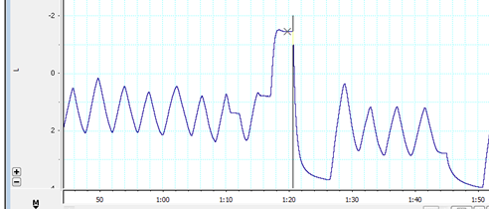
Scale: Volume-___liters= ____mm Rate: _____seconds = ___mm paper
TV: IRV:

ERV: VC:

FEV₁ (L) %FEV₁ .

Breathing Rate: MRV:

Is each value normal, low or higher than average?

Any reason to think this person has asthma? Why or Why not?

2 pts: Spirometry #3: Assume this athlete was 360 pounds and 6 foot 8 inches tall
Calculate TV, Breathing Rate, MRV, IRV, VC, ERV, FEV₁ (L) and FEV₁ (expressed as a percent of VC). Are these values normal, low or higher than average? Show math, scales, and answer (liters, breaths/min, %FEV₁) for this recording
Liter Scale FourTVs IRV FEV1 TVs ERV
Scale: Volume-___liters= ____mm Rate: _____seconds = ___mm paper

TV: IRV:

ERV: VC:

FEV₁ (L) %FEV₁ .

Breathing Rate: MRV:

Is each value normal, low or higher than average?

Any reason to think this person has asthma? Why or Why not?

2 pts: Spirometry #4: Assume this child was 75 pounds and 4 foot 1 inches tall
TV, Breathing Rate, MRV, IRV, VC (use estimate after IRV), FEV₁ (L) and FEV₁ (expressed as a percent of VC). Are these values normal, low or higher than average? (ERV was not directly recorded-estimate from FEV1 slope: +0.4L to -2.7L= VC= 3.1L so…ERV= 3.1L – TV – IRV)
Does this person have asthma? Why/Why not?
Show math, scales, and answer (liters, breaths/min, %FEV₁) for each of the following spirometry recording:

Liter Scale Four TVs IRV FEV1 four TVs ERV
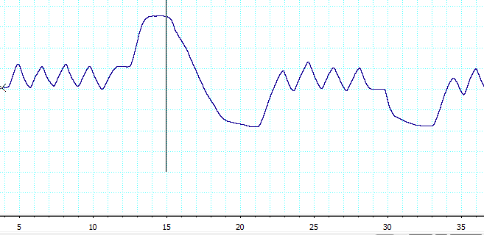

FOR LEFT or Y-axis ASSUME each box is 500 ml or 0.5 Liter
Scale: Volume-___liters= ____mm Rate: _____seconds = ___mm paper
TV: IRV:
ERV: VC:
FEV₁ (L) %FEV₁ .
Breathing Rate: MRV:
Is each value normal, low or higher than average?

Any reason to think this person has asthma? Why or Why not?

(2 pts) Compare and Contrast two things in words (10-20 words each)

1Pt: How much and why do respiratory volumes (VC, TV, etc) differ when men and women are compared? (Ballpark predictions are fine)

1Pt: How much and why would respiratory volumes (VC, TV, etc) differ when the same 155 pound woman is compared at rest and when exercising? (Ballpark predictions are fine)

